

**THE ASYLUM SEEKERS'**

**GUIDE IN PARIS**

MARCH 2019

ASYLUM, WHAT IS THAT?

**SEEKING ASYLUM** means you are asking for a country's protection because you are in danger as you have been persecuted and threatened in your origin country.

**THE PROCEDURE FOR SEEKING ASYLUM** enables to determine whether you are eligible to become a refugee.

**THE REFUGEE STATUS** or **SUBSIDIARY PROTECTION** enables you be protected by the

French State :

* you are allowed to live on French territory
* acquire French documents to work legally
* ask to have your family come over.

HOW TO USE THIS GUIDE :

**PINK** squares show addresses and information for **unacompanied minors**

**(under 18)**

**THE NEXT PAGE :**

■I

**shows you how to navigate through the different chapters of the guide.**

Postal address

**E** Email address

© Opening times

© Information

**S** Telephone number ® Metro

TABLE OF CONTENTS

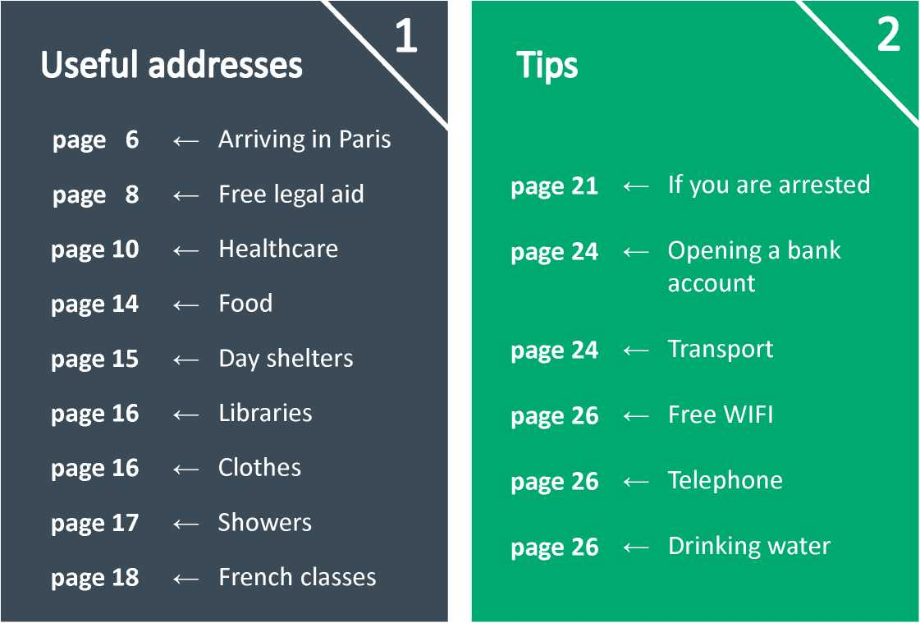

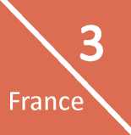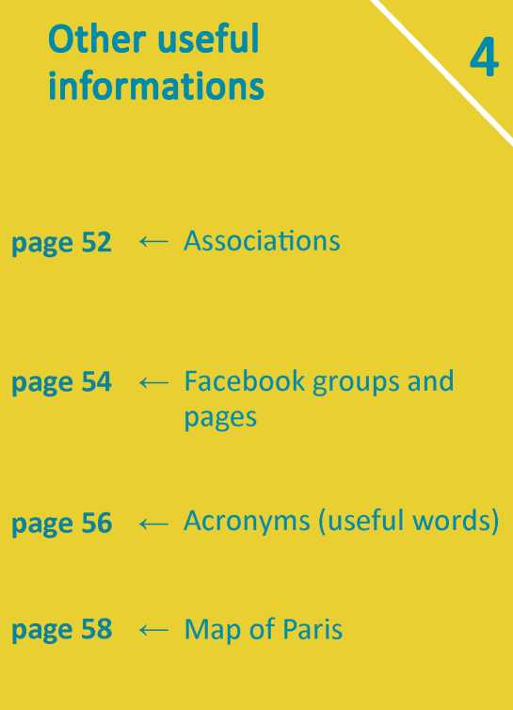

Procedures

**page 28** <— Ayslum Claim in

**page 38** <— Appeal the decision

**page42** ^Applying for reconsideration **(reexamen)**

**page 44 <—** If you have been granted a  
refugee status

Your social rights

**page 46** Domiciliation

**page 47** Financial benefits

**page 48** Access to health

**page 50** Access to housing

**page 50** Enrolling children in

school

**page 50** Employment

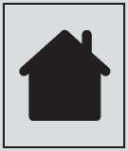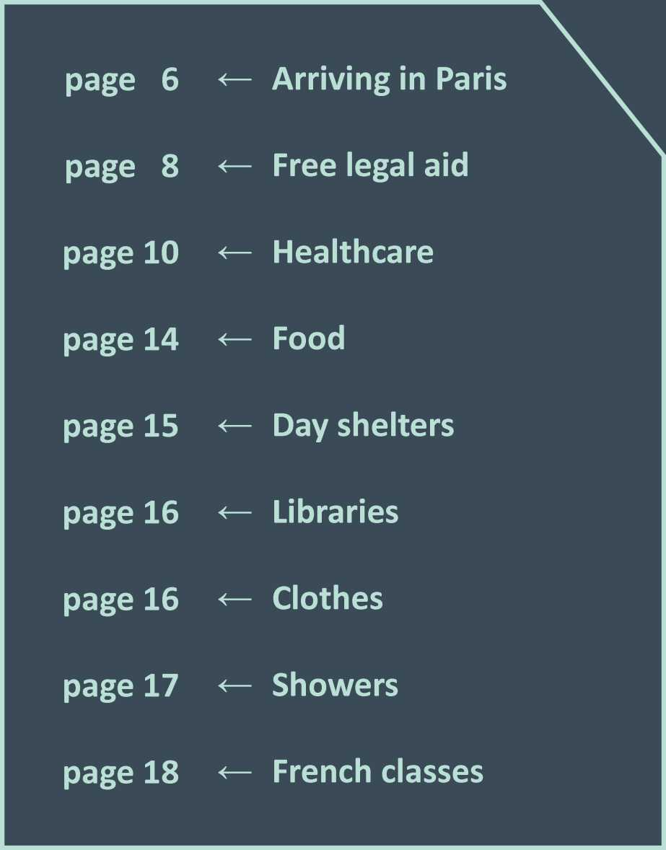

EMERGENCY PHONE

NUMBERS

**f-**

**18**

**f-**

**17**

**USEFUL**

**ADDRESSES**

**115**

FIREMEN

Report a dangerous situation. (accident, fire, sick person ...)

POLICE

Call the police in case of aggression to get some help.

SAMU SOCIAL

Emergency accommodation for one or a few nights.

You can call 24 hours but you might have to wait 2h or more for someone to answer. The more often you call, the more chance you will have to get a space.

Ask for an interpreter of you own language.



**ARRIVING IN PARIS**

**First procedures**

UNACCOMPANIED MINORS (UNDER 18)

**FOR ADULTS**

**IF YOU ARE OVER 18, IF YOU ARE ALONE, A COUPLE OR A FAMILY**

To apply for asylum when you arrve in Paris, call this number to get an appointment

**OFII number: 01 42 500 900**Monday- Friday : 9am-3:30pm, THIS NUMBER IS NOT FREE!

When you call, wait for the language options, they offer many language options

**DAY CENTRES**

To get housing, or **if you can't access a phone**, go to one of these 3 “accueil de jour” (**DAY CENTRES)**.

They offer : day shelter, showers, meals, WIFI, free call to the OFII number and help for your procedure. It's a good way to get your procedure started.

Arrive before opening time- the number of places is very limited.

PARIS DAY CENTRE 1 **(men)**

* 1, boulevard du Palais - 75004 Paris ® Cite (line 4 )

Q Monday- Friday 9am- 4pm

PARIS DAY CENTRE SUD **(men)**

* 82 avenue Denfert-Rochereau - 75014 Paris

® Raspail (line 4lor 6)

® Monday - Friday 9am- 4pm

PARIS DAY CENTRE BASTILLE

**(women, couples, families)**

* 3 rue des Lesdiguieres - 75004 Paris

® Bastille (line 1 , 5, 8)

O Every day 10am- 7pm

**HOUSING**

You can get access to housing through DAY CENTRES : 10-30 people from the DAY Centre are sent every day to a temporary accommodation centre (*CAES*). Be prepared to return several days to the DAY CENTRE before being able to get housing.

These centres are usually for people who:

* have not yet started their asylum application
* have already been to the prefecture and have obtained their certificate of asylum application *(recepisse)*

**Warning:** If you have already had housing with the OFII or if you no longer have right to accommodation, you are likely to be denied new housing but you can still try.

1. **Go to one of these 3 evaluation centres : no need to get an appointment**

DEMIE **(in Paris)**

A 5, Rue du Moulin Joly, 75011 Paris ® Couronnes (line 2 )

01 58 30 14 50

O Monday, Tuesday, Thursday, Friday 9am-5pm / Wednesday 11am-5pm (GET THERE EARLY)

PEMIE **(in Bobigny)**

# 1-15 rue Benoft Frachon, 93000 Bobigny ® Bobigny-Pantin Raymond Queneau (line 5 )

01 82 46 81 42

G) Monday to Friday 9am-12:30 / 1:30pm- 5pm Closed Thursdays afternoon

PEOMIE **(in Creteil)**

A 6 rue Albert Einstein, 94000 Creteil ® Creteil-l'Echat (line 8 )

01 42 07 09 02

O Monday to Friday 9:30am-5:30pm

1. **OBTAIN CARE BY THE CHILD WELFARE SERVICES: *lAide Sociale a 1'Enfance (ASE)*** The French State is legally obliged to protect and to take charge of children under 18 in French territoy without a legal guardian (through the Child Welfare Services)

First, **the State has to acknowledge your minor status.** The recognition procedure takes time and there are several steps involved in the age determination.

1. **EVALUATION INTERVIEW**

To prove you are minor (under 18 years old) you will need to go to an evaluation centre. For that, you can go to the police who will take you to an evaluation centre, or directly go there yourself.

You should get your **1st interview** quickly and possibly be allowed accommodation while you wait for your 2nd interview.

Your **2nd interview** will take longer and you will be asked about your identity, country, family, story, education and about your journey to France.

You will get an answer a few days after the 2nd interview. If they refuse your minor status, they must give you a refusal attestation indicating the reasons for said refusal. It is very important to keep that document for the next procedure!

1. **IN CASE OF REFUSAL**

You can request a 2nd evaluation to a juvenile judge with the help of organisations (**Adjie**) or lawyers (**Antenne des Mineurs**) : page 8. During the legal appeal procedure, you won't be taken care of by the State : it will be difficult finding accommodation.

Keep close to organisations and distribution spots who help unaccompanied foreign minors (**MSF, les Midi du Mie, SAJE**- page 14-15) **Doctors Without Borders** (Medecins Sans Frontieres, MSF) provide a daycare centre reserved for minors. It offers orientation, psychological follow-up, and long-term shelters (page 15).

1. **ASYLUM APPLICATION FOR**

**MINORS**

When you are asked to be identified as a minor and are taken in charge by social services (ASE) you can start your asylum application.

It is the same procedure as for adults. You have to be represented by an ad hoc administrator (AAH) to help you with your request.

This administrator will represent you and help you with the procedure.

**WARNING** : The AAH doesn't necessarily have good knowledge of asylum procedures: you have to ask help from specialized organizations.

Important : Children under 18 can't get the allo­cation for asylum seekers (ADA).

Only the social services (ASE) can host foreign children under 18, so you can't be housed in accomodation centers for adults.



*Help and advice for your procedures*

**IF YOU NEED HELP FOR :**

**ASYLUM PROCEDURE** • **DUBLIN PROCEDURE** • **RESIDENT PERMIT** • **TELEPHONE HELPLINE** •

UNACCOMPANIED MINORS (UNDER 18)

ADJIE

© Legal assistance for **unaccompanied minors**

* 49ter avenue de Flandres, 75019 Paris CD Riquet (line 7)

13 [contact@adjie.fr](mailto:contact@adjie.fr)

© Monday 6pm-10pm, Saturday 9am-2pm Arrive 2 hours before opening time and note your name on the list

ANTENNE DES MINEURS

® FREE. Lawyers for **unaccompanied minors** who received a refusal of minority recognition

* 29-45 Avenue de la Porte de Clichy 75017 Paris

CD Porte de Clichy (line 13)

© Tuesday and Friday 9:30am-12:30,

Thursday 2pm-5pm

ADULTS

CEDRE • •

© Legal advice on **asylum procedure**, on **the Dublin procedure**, and **for people who came back in France after their transfer**

* 23, boulevard de la Commanderie, 75019 Porte de la Villette (line 7 or tram 3b) 01 48 39 10 92/ **Be there before 8:30am**

© Monday, Tuesday, Thursday 9am-5pm.

**Information on Dublin procedure** : Monday and Tuesday at 9am.

LA CIMADE PARIS BATIGNOLLES

* 46 boulevard des Batignolles,75017 Paris

CD Rome (line 2) 01 40 08 05 34

© Asyl um seekers and refugees: • • Tuesday 9am-12, **Come at 8am!**

© Resident permit:

Wednesday and Thursday 9:30am-11:30am and 2:30pm-4:30pm

© Helpline by phone: •

Monday 2:30pm-5:30pm and Wednesday 9:30am-12:30

LA CIMADE PARIS LUXEMBOURG

A 58 Rue Madame, 75006 Paris

CD Saint Placide (line 4 ) / CD Rennes (line 12) or CD Luxembourg (RER ®) 8 01 42 22 75 77 **CD** Asyl um seekers and refugees: • Tuesday 9:30am-12, **no Dublin procedure CD** Resident permit : Wednesday 9am

-12, Thursday 3pm-6pm and 7pm-8pm

A.P.T.M •

239 rue de Bercy, 75012 Paris

**CD** From Monday to Thursday 9:30am-12 and 2pm-5pm, Friday 9:30am-12

BAAM • •

© Legal advice for asylum seekers - Help for OFPRA case, CNDA appeal, Dublin. **No OQTF!** A 2 Place Baudoyer, 75004 Paris

CD Hotel de Ville (line 1 )

® Wednesday and Friday 5pm-8pm

CLINIQUE JURIDIQUE^

© Help for the Ofpra interview and wiriting your story *(recit),* help for CNDA appeal

* Espace soldiarite Ramey- Secours populaire / 6 passage Ramey, 75018 Paris CD Marcadet Poissonniers (line 4lor © © Saturday 10am-12

13 [asile.cliniquejuridiqueefb@gmail.com](mailto:asile.cliniquejuridiqueefb@gmail.com)

MRAP COMITE LOCAL 19/20 • • © Information, orientation, follow up - **No Dublin procedure**

* 43 boulevard de Magenta, 75010 Paris CD Chateau d'Eau (line 4 )

CD Gare de l'Est (lines 4 /5 /7 or CD) [accueil@mrap.fr](mailto:accueil@mrap.fr) 8 01 53 38 99 99

CD **Reception** and helpline by phone

Monday to Friday 10am-12:30

PERMANENCE INTER- ASSOCIATIVE • (ATMF, Domasile, Cimade, GISTI)

**® Emergencies for “Dublin” and OQTF**

* 10 Rue Affre, 75018 Paris

CD La Chapelle (line ll/ CD ® Gare du Nord) 8 01 42 55 91 82 CD Monday 2pm-6pm

ASSOCIATION ASILE •

© Help for the Ofpra interview and wiriting your story (*recit*), help for CNDA appeal, allocation and social security problems

**No Dublin appeal and “reexamen”**

* 65 rue des haies, 75020 Paris

CD Avron (line 2) or Porte Montreuil Tram3b To get an appointment : 8 07 67 04 43 83 / 13 [contact@asile-en-france.org](mailto:contact@asile-en-france.org) / No appointment : © Friday 10am-12

LIGUE DES DROITS DE L'HOMME^ • •

* 219 Bd Macdonald, 75019 Paris

CD Rosa Parks (tram 3B, CD E )

CD Tuesday 3pm-8pm

Helpline by phone for Legal advice

8 01 56 55 50 10

© Lundi au Vendredi 10am-1pm

SCIENCES-PO REFUGEE HELP •

© Help for the Ofpra interview and wi your story (*recit*)

A Maison des Initatives Etudiante 50 rue des tournelles 75003 Paris

CD Bastille(ligne 1 /5 /8 )

© Thursday 5pm-7pm

GISTI •••

© Helpline by phone for legal advice (try to call several times) 8 01 43 14 60 66

© Monday to Friday: 3pm-6pm and also from 10am to 12 Wednesday and Friday

LA CIMADE BELLEVILLE

* 25 rue Fessart, 75019 Paris

CD Jourdain (line 11)

© Resident permit

Monday before 10:30am, Tuesday 2-9pm

FASTI

© Resident Permit

* 58 rue des Amandiers 75020 Paris

CD Menimontant (line 2)

© Tuesday and Thursday : 2pm-5pm

Legal advice for LGBT

*(Lesbian, gay, bisexual, transgender)*

BAAM PERMANENCE LGBT •

**Appointment needed**

* “Les Grands Voisins” 74 Avenue Denfert- Rochereau, 75014 Paris- Residence Colombani (in front of the “Pierre Petit” building)

CD Denfert Rochereau (line 4|or 6)

13 [baam.lgbt@gmail.com](mailto:baam.lgbt@gmail.com) © Tuesday 6-8pm

ARDHIS •

#63 rue Beaubourg, 75003 Paris

CD Rambuteau (line ©

01 43 57 21 47 13 [contact@ardhis.org](mailto:contact@ardhis.org)

© Meetings about the asylum process every 2nd Saturday of the month : 10:30am

PASS (HOSPITALS)

Free medical consultation and social services without health insurance (come early) -

**It can help to be accompanied by a french speaker**

UNACCOMPANIED MINORS

(UNDER 18)

**WARNING**, for medical consultation for minors you need a LETTER FROM A DOCTOR before going to hospital (except in emergencies).

If you don't know any doctor, you may go to Medecins du Monde mobile clinic (see page 13) and ask the doctor to write you a letter for the hospital.

**® Appointment needed**

HOPITAL ROBERT-DEBRE

© Medical consultations for **minors** and **pregnant women**

**No appointment needed.**

#48 boulevard Serurier, 75019 Paris ©Pre Saint-Gervais (line 7 BIS)

a 01 40 03 24 94

© Monday to Friday 9am-12 and 2pm-4pm

**Closed on Tuedays morning and Wednesdays afternoon**

© Entrance by green area (“point vert”)

H OPITAL ARMAND-TROUSSEAU

© Medical consultation for **minors**

* 26 avenue du Docteur Arnold-Netter, 75012 Paris

© Bel-Air/Picpus (line 6)

S 01 44 73 69 09 (Medico-surgical Pediatric Emergency Service)

S 01 44 73 68 75 (Emergency doctor for children)

S 01 44 73 68 39 - 01 44 73 62 62 (Social services)

© Call Social Services to make appointment with sociial worker and a doctor.

© Emergencies : open 24 hours

MEDECINS DU MONDE

© Unaccompanied **minors**

* 15 Boulevard de Piepus, 75012 Paris

© Bel Air (line 6)

01 43 14 81 84

© Wednesday 2:15pm-5pm

**No appointment needed**

(medical-psycho-social consultation)

ADULTS

HOTEL-DIEU

© General medical consultation for adults

**No appointment**

* 1 place du Parvis Notre-Dame, 75004 Paris

© Saint Michel/Cite (line 4-© (B )

S 01 42 34 88 98 / 01 42 34 80 77 (Social service)

© From Monday to Friday. Come at 7am

HOPITAL BICHAT - CLAUDE-

BERNARD

© Medical consultation for adults

- Emergencies only- **No appointment needed.**

* 46 rue Henri-Huchard, 75018 Paris

© Porte de Saint-Ouen (line 13)

a 01 40 25 80 80

© 24h/7j- Make an appointment if needed and with d octor's advice.

HOPITAL SAINT-LOUIS

© General medical and dermatology consultation for adults.

* 1 avenue Claude-Vellefaux ,75010 Paris a 01 42 49 91 30

© Colonel Fabien (line 2)

© To make an appointment : Monday to Friday 8:30am-4:30pm by phone.

© Without an appointment, come early around 6:30am.

HOPITAUX LARIBOISIERE AND FERNAND-WIDAL

© Medical consultations for adults

**Appointment needed**

**Ask for “Consultation Arc-en-ciel”**

* 2 rue Ambroise-Pare, 75010 Paris

© Gare du Nord (line 5 and Jand © (B ) a 01 49 95 65 65 - 01 49 95 81 24 © From Monday to Friday 8am-4:30pm Come early.

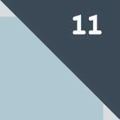# 184 rue du Faubourg Saint-Antoine, 75012, Paris

HOPITAL SAINT-ANTOINE

Polyclinic

© Faidherbe- Chaligny (line 8 ) or

© Nation (line O)

© From Monday to Friday. 8am-5pm

Come early

CENTRE HOSPITALIER DE SAINT­DENIS

© General and dental medical consultation.

**® Call for Appointment**

# 2 rue du Dr Pierre Delafontaine, 93200 Saint-Denis

© Basilique de Saint-Denis (line 13 )

a 01 42 35 60 00 (Consultation)

a 01 42 36 61 21 - 01 42 35 60 25 (Social

Service)

Monday 1pm-2:45pm : Dental

Go to the hospital social centre 2 hours before the appointment.

HOPITAL BICETRE

© Medical consultations for adults (Polyclinic- Porte 39)

# 78 rue du General Leclerc, 94043 Le Kremlin-Bicetre

© Le Kremlin-Bicetre (line 7)

a 01 45 21 73 30

8 Social services: 01 45 21 30 91

**© Call for appointment (everyday from 8am to 6pm)**

MEDICAL SOCIAL CENTRES (CMS)

MENTAL HEALTHCARE

CENTRES

CENTRE MEDICO-SOCIAL BELLEVILLE

LE CENTRE MINKOWSKA

218 rue de Belleville, 75020 Paris

® Telegraphe / Place des fetes (line 11) 01 40 33 52 00 -

**Call for appointments monday**

**morning**

Generalist: **Appointment needed**

Monday, Tuesday, Wednesday and Friday

9am-12.

**Only with the recommandation of a doctor or social assistant**

**Appointment needed** (2-3 months delay)

12 rue Jacquemont, 75017 Paris

La Fourche (line 13)

Psychiatric and psychological

Aids, Tuberculosis, etc.. tests Monday

to Friday without appointment : 9am or 1:30pm.

You can take an appointment to meet a social service

consultation. FREE 01 53 06 84 84 © To make an appointment : contact the reception open Monday to Friday 9:15am- 1pm and 2pm-6pm.

CENTRE PRIMO LEVI

**FREE** - For torture or political violence victims.

**Appointment needed** (2-3 months delay)

107 avenue Parmentier, 75011 Paris (under the porch on the right, 2nd floor) ® Republique (line 0/ 5 8 / 9 ) © Monday to Friday 9:30am-1pm

Helpline by phone Monday, Wednesday and Friday 2pm-5pm.

01 43 14 88 50

MEDICAL

ASSOCIATIONS

MEDECINS DU MONDE -

CENTRE D'ACCUEIL,

D'ORIENTATION ET D'ACCOMPAGNEMENT (CAOA)

*(Orientation and help centre)*

**® Without appointment:** medical and social consultations.

**With appointment:** psychological and legal consultations.

A 15 bd de Picpus, 75012 Paris '

® Bel Air (line 6 )

Monday, Tuesday, Thursday, Friday: come at 8am and take a ticket.

@ 01 43 14 81 81

MEDECINS DU MONDE

CASO

® Shelter, health and orientation Centre

(CASO)

A 8/10 rue des bles, 93210 Saint-Denis ® La Plaine-Stade de France (@ ) and

Front Populaire (line 12)

**S 01 55 93 19 31**

® Monday, Tuesday, Thrusday 9am-1pm and 2pm-5pm, Friday 9am-1pm without appointment

Come very early

MOBILE CLINIC

exiles in the street.

Doctors and Arabic, Pachto-Dari interpreters

® Monday and Wednesday 1:30pm-5pm APorte de la Chapelle (line ©)

Friday 1:30pm-5:30pm

APorte d'Aubervilliers (tram 3b)

LE BUS DENTAIRE

Emergency dental care.

For adults only

Check out the planning online S 06 80 00 94 21 : call for advice

@ : [www.busdentaire.fr](http://www.busdentaire.fr)

HELP LINE

COMEDE - COMITEE FOR REFUGEES' HEALTH

Assistance and advices for medical treatment.

Legal advice in right of foreigners.

S 01 45 21 38 93

From Monday to Thursday, 2.30pm-5.30pm

CIMADE- COMEDE

Assistance and expertise on **right of residence for medical reasons**, access to health care services and to social benefits for foreigners living in Ile-de-France.

S 01 43 52 69 55

Wednesday,

9.30am-12.30pm and 3pm-5.30pm

Friday, 9.30am-12.30pm

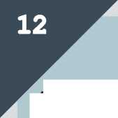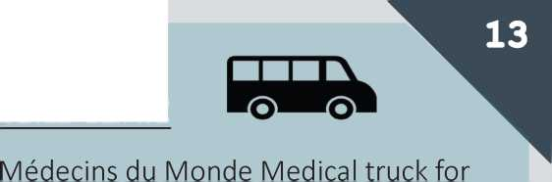



**DAY SHELTERS**

1 i X

BREAKFAST

P'TIT DEJ' SOLIDAIRES

Eole Garden, 75019 Paris

Entrance rue d'Aubervilliers facing “rue du

Maroc"

© Stalingrad (line 2 / 5)

© Every morning, around 8:30am.

LARMEE DU SALUT

In front of *T1* Boulevard Ney, 75018 Paris © Porte de la Chapelle (line 12) © Every morning from 8:30am

BREAKFAST / LUNCH

LES MIDIS DU M.I.E (MINORS) Breakfast

Q Monday, Tuesday, Wednesday 10:30am - 12h

Rue du Moulin Joly © Couronnes (l. 2)

Lunch :

© Thursday-Friday 12h

Saturday-Sunday 12:30

Jardin de la rue Pali-Kao © Couronnes (line 2)

LE SAJE (MINORS)

© Monday, Tuesday,Wednesday, Friday: 1pm-4pm

A Corner of rue du Moulin Joly and rue de la Fontaine au roi © Couronnes (line 2)

RESTOS DU COEUR/L'UN ET LAUTRE A 7-15 avenue Porte de la Villette 75019 Paris,

© Porte de la Villette (Line 7)

© Everyday 11am- 1pm

DINNER

REFETTORIO PARIS

Foyer de la Madeleine (in the crypt of the church: right hand side entrance) © Madeleine (line 8 /©/©) ® FREE. Registration needed with association © Monday to Friday : come between 6:30pm and 7:30pm to get registration information.

LARMEE DU SALUT

A 11 rue Leon Jouhaux, 75010 Paris © Republique (line 5) © Everyday 6pm-8pm

LA GAMELLE DE JAURES

Jardin Anais Nin, 75019

Rosa Parks or Porte d'AuberviHiers tram3b © Monday at 8:00pm

LA CHORBA / L'UN ET LAUTRE

A 7-15 avenue Porte de la Villette 75019 Paris © Porte de la Villette (Line 7)

© Everyday 5:30pm-8pm

UNE CHORBA POURTOUS © Jaures (line 2 / 5 / 7 **bis**) 75019 © Monday to Friday at 5pm

RESTOS DU COEUR

A Jardin Anais Nin, 75019

© ®) Rosa Parks or Porte d'Aubervilliers tram3b © From Tuesday to Friday 8pm

LE GANG DE LA POPOTE

Place Pajol 75018 © Marx Dormoy (line 12) © Wednesdays at 7:30pm

COLLECTE DU 75

Jardin Anais Nin, 75019

© Rosa Parks or Porte d'AuberviHiers tram3b © Every sunday at 7pm

DAY CENTRES (ASSOCIATIONS)

**FREE -** To rest and have access to different forms of help depending on the centre (hot drinks, charge your phone, wifi, advice, etc.)

UNACOMPANIED MINORS (Under 18)

CENTRE DACCUEIL DE JOUR POUR MINEURS (MSF)

*Reception centre for unaccompanied minors*

101 bis avenue Jean Lolive 93500 Pantin © Eglise de Pantin / Hoche (line 5) © Monday to Friday 9am-7pm **a Call before coming** 01 40 21 29 29

FAMILIES

ESI FAMILLES

2/4 rue Georges Pitard 75015

© Pernety (line 13) a 01 44 19 83 12

© Monday to Friday 10am-1pm (and the afternoon if appointment taken in the morning)

ADULTS

AUTREMONDE

30 rue de la Mare 75020 Paris

©Couronnes (line 2), ©Pyrenees (line 11) © Wednesday, Friday 2pm- 5:30pm and Sunday 3pm- 6pm.

CAMRES

11 Passage de Dubai 75010 Paris © Gare de l'Est (line 4 /5 /7) © Monday and Wednesday 9am- 12:15pm/1:45pm- 4:45pm, Tuesday and Friday 9:30am-12:15pm, Thursday 9:30am- 12:15pm / 1:45pm-4:45pm

LA MAISON DU PARTAGE

32 rue Bouret 75019 Paris

© Bolivar (line 7 BIS) / Jaures (line 2|5 7**bs)** © Monday to Sunday 9am-12:30 and 2 pm-

5pm. **Closed on Saturdays**. a 01 53 38 41 30

AGORA (EMMAUS)

* 32 rue Bourbonnais 75001 © Chatelet(line

1 / 3 /7 /©/©/© ) © Monday, Tuesday,

Wednesday, Friday 9am-12 (and the afternoon with appointment), Thursday 2pm-4pm

ESI SAINT-MA RTIN

* In front of 31 bd Saint-Martin 75003

© Republique (line 5 / 3 /11 / 9 / 8)

© Monday to Friday 9am-12:30/2pm-4:30pm and 9th, 10th ,23rd, 24th March. **Come at 8am!**

MAISON DANS LA RUE - BICHAT

**Q** Single Men and Women

35 rue Bichat 75010 © Goncourt (line 11)

© Monday, Tuesday, Friday: 9am- 12:30/1:30pm-5pm and Wednesday 9am- 12:30/Thursday 9am-12 and 13:30pm-17pm

MAISON DANS LA RUE

18 rue Picpus © Nation (line 2)

© Monday, Tuesday, Thursday, Friday 8am- 12/2pm-5pm and Wednesday 2pm-5pm

WOMEN

HALTE FEMMES

# 16-18 passage Raguinot 75012

© Gare de Lyon (line 1 /14)

© Monday to Friday 8:30am-12:30 and

Tuesday, Wednesday 1:30pm-8pm and Sunday, holidays 9am-4pm

HALTE AIDE AUX FEMMES BATTUES

For abused women victims of violence

A 17 rue Mendelssohn 75020

© Porte de Montreuil (line 9)

© Monday 9:30am-12 / 1pm-5pm,

Tuesday, Wednesday, Friday 1pm-5:30pm

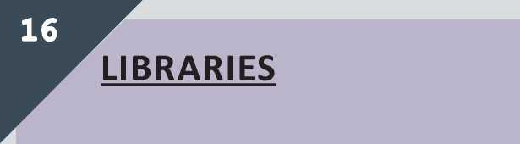Tuesday, Thursday, Friday: 1pm-7pm and Wednesday, Saturday: 10am-6pm

BIBLIOTHEQUE GOUTTE D'OR

2 rue Fleury, 75018 Paris ® Barbes Rochechouart (line 4 )

BIBLIOTHEQUE MAURICE GENEVOIX

19 rue Tristan Tzara, 75018 Paris

® Marx Dormoy (line [1] [2])

® Tuesday, Thursday, Friday 2pm-6pm and Wednesday, Saturday: 10am-6pm

BIBLIOTHEQUE HERGE

2 rue du Departement, 75019 Paris

® Stalingrad/La Chapelle (line 2)

® Tuesday, Thursday, Friday 1pm-6:30pm and Wednesday and Saturday 10am-6pm

BIBLIOTHEQUEV CLAUDE LEVI- STRAUSS

41 avenue de Flandres, 75019

® Riquet (line 7 )

® Tuesday, Thursday, Friday 1pm-7pm Wednesday 10am-7pm and Saturday 10am- 6pm

BIBLIOTHEQUE VACLAV HAVEL

26 esplanade Nathalie Sarraute, 75018 Paris

® Marx Dormoy (line 12 ),La Chapelle (line 2)

® From Tuesday to Friday 2pm-7pm, Saturday 10am-6pm

MEDIATHEQUE FRANCOISE SAGAN

A 8 rue Leon Schwartzenberg, 75010 Paris

® Gare de l'Est (line 4 /5 /7 )

® Tuesday to Friday 1pm-7pm and Saturday

10am-6pm and Sunday 1pm-6pm

MEDIATHEQUE DON QUICHOTTE A 120 avenue du president Wilson, 93210 Saint-Denis

® Front Populaire (line 12)

® Tuesday 3pm-8pm, Wednesday and Friday 1pm-6pm, Thursday 3pm-6pm, Saturday : 10am-6pm

BIBLIOTHEQUE DES SCIENCES ET DE L'INDUSTRIE

A Cite des sciences et de l'industrie- 30, avenue Corentin-Cariou, 75019 Paris ® Porte de la Villette (line 7) ® Tuesday to Sunday: 12-6:45pm

VESTIAIRE DE L'EGLISE SAINT-BERNARD

**CLOTHES**

SHOWERS

®FREE -

Individual shower cubicle Bring your own towel and soap

BAINS-DOUCHES OBERKAMPF

Accessible to disabled people

42 rue Oberkampf, 75011 Paris Oberkampf (line 5)

From monday to saturday 7:30am-1pm, Sunday 8am-12:30, Closed on thursday

BAINS-DOUCHES BIDASSOA

*T1* rue de la Bidassoa, 75020 Paris ©Gambetta (lineK ) ® From Tuesday to Saturday 12-6pm

BAINS-DOUCHES NEY

Accessible to disabled people

134 boulevard Ney, 75018 Paris

Porte de Clignancourt (line 4 ) ® Monday, Tuesday, Wednesday, Friday, Saturday 7:30am-1pm. Sunday 8am-12:30.

BAINS-DOUCHES PETITOT 1 rue Petitot, 75019 Paris Place des Fetes (line 11)

® Tuesday to Saturday 12 - 6pm

BAINS-DOUCHES DES HAIES

*T1* rue des Haies, 75020 Paris

Buzenval (line 9)

® Tuesday to Saturday 7:30am-1pm Sunday 8am-12:30

BAINS-DOUCHES PYRENEES

296 rue des Pyrenees, 75020 Paris

Gambetta (line 3)

® Monday, Tuesday, Thursday, Friday, Saturday: 7:30 - 1pm

Sunday: 8am-12:30

LA MAISON DU PARTAGE

Provide soap, shampoo, towels and razors / Breakfast included

32 rue Bouret, 75019 Paris ® Bolivar (line 7 BIS) Q Open Monday to Friday from 9am-12:30 and 2pm-4:30pm

Open one sunday out of two alternately.

**Come the day before to make an appointment**

BAINS-DOUCHES ROUVET

1 rue Rouvet, 75019 Paris

® Corentin Cariou (line 7)

Q Tuesday to Saturday 7:30am - 1pm and

Sunday 8am - 12:30

BAINS-DOUCHES MEAUX

18 rue de Meaux, 75019 Paris ® Colonel Fabien (line O)

Q Every day except Wednesday 7:30am-

1pm and Sunday 8am-12:30pm

BAINS-DOUCHES LES AMIRAUX

6 rue Hermann-Lachapelle, 75018 Paris ® Simplon (line Q)

Q Tuesday to Saturday: 12 - 6pm

LES DEUX PONTS

8 rue des deux ponts, 75004 Paris

® Pont-Marie (line 7)

Q Monday, Tuesday, Wednesday, Friday 7am-5:30pm

Saturday 8am-5pm / Sunday 8am-11

LA MAISON DANS LA RUE-BICHAT

35 rue Bichat, 75010 Paris

Goncourt (line 11) S 01 40 18 04 41 Q Monday to Friday: 9am-12:30am and 1:30pm - 5:30pm. (Closed Wednesday afternoon)

**Come the day before to make an appointment.**

FRENCH CLASSES

WITHOUT REGISTRATION

BIBLIOTHEQUE COURONNES

© For minors- FREE

# 66 rue des Couronnes, 75020

® Couronnes (line 2)

©Thursday and Friday 10am-12

BPI - BIBLIOTHEQUE

PUBLIQUE D'INFORMATION

Centre Pompidou, entrance rue Beaubourg- ® Rambuteau (line 11) and

Hotel de Ville (line 11 /1 )

On the second floor of the library

@ **Free** space for self-study in French © Open from 12 to 10pm (Monday- Wednesday-Thursday-Friday) and from

11am to 10pm (Saturday- Sunday- holidays). Closed on Tuesday.

@ **Free** conversation workshops, without prior registration, arrive 20 minutes before. (Limited number of places (6 people per course).

© Friday: Beginner level: 1pm Intermediate level: 2pm, 4pm, 6pm

STALINGRAD CLASS

A Place de la rotonde, 75019 Paris

On the stairs, next to “Quai de Loire“ © Everyday from 6:30pm-7:30pm

LA FEMIS

A 6 rue Francoeur (in classrooms of the school)

® Lamarck (line ©

Jules Joffrin (line ©

or Chateau Rouge (line **0)**

© Monday and Friday 6pm - 8pm.

WITH REGISTRATION

ATOUTS COURS

**® 60€ the year** / Go there to registrate.

© 3 times 2 hours every week

72 Rue Philippe de Girard

® La Chapelle (line 2 ),Marx Dormoy (line 12)

ESSOR

**Q 60€ the year** / Go there to registrate.

15 passage Ramey

® Marcadet Poissonniers (line 4|or © **a** 07 81 86 79 15 / 06 51 82 31 92

© Reception on Tuesday 10am - 6pm and Wednesday-Thursday-Friday 2pm - 6pm

BAAM - FRENCH LESSONS (“BIENVENUE CHEZ TOI”)

**FREE -No registration needed** *Levels* Alpha / ecriture = reading and writing **ALL LEVELS** A1/A2 = beginners

B1/B2 = intermediary

**COURS DE FRANQAIS**

**mars - 03/2019**

The BAAM lessons are changing every month,

stay informed on the site:

<https://baamasso.org/en/learning-french>

|  |  |  |  |  |  |
| --- | --- | --- | --- | --- | --- |
| **Jour/Day jjj/ *fM*** | **Horaire/Hour O&lc /** | **Lieu/Place *tj* 1* jii\*** | **Adresse / Address**  **IPJJI *1*** | **Metro / Subway** | **Niveau / Level nJa-< / jjXma** |
| **Lundi - Monday** | **10:00-12:00** | **Cafezoide** | **92 BIS QUAI DE LA LOIRE** | © LAUMIERE | **Alpha/A1/A2/B1** |
|  | **18:00-20:00** | **La F6mis** | **6 RUE FRANCOEUR** | ® LAMARCK CAULAINCOURT | **Alpha/A1/A2** |
|  | | | | | |
|  | **10:00-12:00** | **Maison de la** | **25 RUE J-J ROUSSEAU,** | RER C IVRY SUR SEINE | **A1/A2/B1/B2** |
|  | **Citoyennete** | **IVRY SUR SEINE** |
| **MARDI-**  **- TUESDAY** | **10:30-12:30** | **Centre Paris Anim'** | **26 ALLEE du CHEF D'ESCADRON de GUILLEBON** | 0 ® MONTPARNASSE- BIENVENUE | **Alpha/A1/A2** |
|  | **16:00-18:00** | **Local PCF 13dme** | **75 BOULEVARD VINCENT AURIOL** | 6 CHEVALERET | **A2** |
|  | **19:00-21:00** | **La Clairidre** | **60 RUEGRENETA** | © SENTIER | **Tous niveaux** |
|  | **10:00-12:00** | **Bibliotheque Goutte d'Or** | **2 RUE FLEURY** | 0© barbEs-rochechouart | **Tous niveaux** |

14:30-16:30

Local PCF 2eme

72 RUE DE CLERY

A1/A2

0 0© STRASBOURG -SAINT­DENIS

Bureau

d'Accueil et d’Accompagnernen: des Migrant.e.s

**-**

**Mercredi - Wednesday**

**Jeudi -**

**Thursday**

**18:30-20:30**

**10:00-12:00**

**10:00-12:00**

**14:00-16:00**

**10:30-12:30**

**ACERMA**

**Bibliotheque Ldvi-  
Strauss**

**Maison de la  
Citoyennete**

**Local PCF 10eme**

**Centre Paris Anim'**

**22 QUAI DE LA LOIRE**

**41 AVENUE DE FLANDRE**

**25 RUE J-J ROUSSEAU,  
IVRY SUR SEINE**

**57 RUE DES VINAIGRIERS**

© JAURES

**Tous nlveaux**

© 0 © STALINGRAD

**A1/A2/B1**

RERC

IVRY SUR SEINE

**A1/A2/B1/B2**

© JACQUES BONSERGENT

**A1**

AUTREMONDE

# 30 rue de la Mare

a 01 43 14 77 85

Couronnes (line 2) Pyrenees (line11)

@ Free / without registration

Call for schedule

@ Many learning programs over the long term including workshops with professional aim: register as soon as possible by phone or on site

**Vend red i -  
. axmJi . Friday**

**14:30-16:30**

**16:30-18:30**

**18:00-20:00**

**Samedi -**

**jjj Saturday 10:00-13:00**

**BiBibliotheque Saint-  
Eloi  
Bibliotheque Saint-  
Eloi**

**26 ALLEE du CHEF  
D'ESCADRON de GUILLEBON**

**23 RUE DU COLONEL  
ROZANOFF**

**23 RUE DU COLONEL  
ROZANOFF**

0® MONTPARNASSE-  
BIENVENUE

€ REUILLY-DIDEROT

0 ( REUILLY-DIDEROT

**La F6mis**

**6 RUE FRANCOEUR**

® LAMARCK CAULAINCOURT

**Alpha/A1/A2**

**Tous niveaux**

**Tous niveaux**

**Alpha/A1/A2**

**Bibliotheque Cite des  
Sciences et de  
I'industrie**

**30 AVENUE CORENTIN CARIOU**

PORTE DE LA VILLETTE

**Alpha/A1/A2**

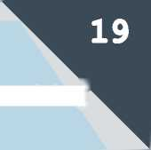

TIPSAND  
ADVICE

**page 21**

**page 24**

**page 24**

**page 26**

**page 26**

**page 26**

**If you are arrested**

**Opening a bank account**

**Transport**

**Free WIFI**

**Telephone**

**Drinking Water**



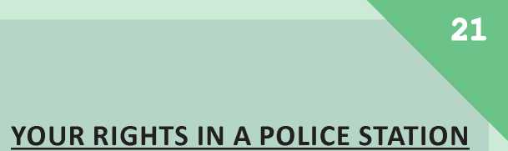

WHAT TO DO IF YOU GET ARRESTED

**As an asylum seeker or undocumented immigrant, you could be subject to identity checks and arrested by the police at any time in the street, in the metro, in a train station, at the prefecture or in a refugee centre.**

**This document explains how to reduce the risk of arrest and how to get out of a retention centre if you have been arrested.**

Documents and information to have with you:

NEVER have your passport with you, keep copies in safe places, and NEVER give your passport to anyone else.

ALWAYS have the following documents with you (or with someone trustworthy who can quickly bring them to you):

* The receipt from your asylum application *(recepisse)* and/or a convocation to the prefecture, a request for legal aid...
* An attestation of domiciliation or accommodation (photocopy)
* Medical certificates and recent prescriptions (photocopy)
* Any document related to your family situation in France (ex: your child's scolarity certificate, marriage certificate...)
* A telephone card and or a phone without a camera.
* The telephone number of a friend or member of an association to be notified IMMEDIATELY if you are arrested or detained.
* A lawyer's phone number if you have one

**Do not sign any documents you don't understand. Ask for an interpreter!**

From the moment you are arrested, the police can retain you for 4 hours maximum to confirm your identity. You can be held in administrative detention («retenue administrative))), for a maximum of 24 hours, if the police needs more time to ascertain your status. If you were arrested while commiting an offense, you can be held 24h in detention *{garde a vue).*

You have four basic rights that could help you be released or prevent a transfer to a detention centre:

* Ask for an **interpreter** in your native language (the more difficult the language the better). Make sure to ask for the exact dialect you wish to talk in. Ex : Sundanese Arabic, Kurdish Sorani...
* Ask to see a **doctor**
* Ask to see your **lawyer** or a government appointed lawyer (Free).
* Ask to phone a **friend or an organisation** you trust to inform them of your arrest and where you are being held. It will thus be easier to help you out.

Answer as precisely as possible the police questions about your personal situation, as your answers will be used to study your situation. You are nevertheless not obliged to answer to some questions if you do not wish to.

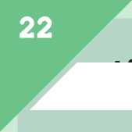**having been arrested, you /o possibilities:**

® YOU HAVE BEEN RELEASED

DIRECTLY go to an association to, understand why they took this decisions.

You might have been issued with an **order to leave French territory (OQTF), a decision for a Dublin transfer or for a «Remise Schengen».** All those decision seek to get you expulsed. You often have only 48 hours to appeal these decisions as from the moment you signed the documents and that they were handed to you.

You need to contact an association VERY QUICKLY (See pages 8-9) that can review your documents and help you. If you have been insulted, mistreated or physically abused by the police, you can file a complaint. You need a medical certificate from a doctor to prove the police physically mistreated you. Contact an association and lawyer to assist you with the procedure.

**(2) YOU HAVE BEEN TRANSFERRED TO A RETENTION CENTRE (CRA)**

From the police station, you may be transferred to a Detention Centre (Centre de Retention Administrative or CRA in French) and risk being expulsed back to your country, to the country reponsible for your asylum application (Dublin procedure) or to the country that granted you protection *{remise Schengen)*

**APPEALING THE EXPULSION DECISION AND RETENTION IN A CRA**

As soon as you arrive in the CRA, contact IMMEDIATELY the association working in the retention centre : ASSFAM, Cimade, Forum Refugies, France Terre d'Asile, Ordre de Malte,Groupe SOS.

They will help you file an appeal against detention and the expulsion decision. If there is no association present (weekends, public holidays, etc.), contact another outside association or your lawyer, if you have one. Remember that you must file the appeal within 48 hours.

Appealing the retention in a CRA

The Judge of Liberties and Detention (JLD) hears appeals and decides after 48 hours whether to extend your retention (+28 days, then +15 days). If the association isn't present and that you don't have a lawyer, you have the right to appeal the expulsion decision and the retention to the police (ask for the *greffe).* Policemen won't be helpfull and will tell you to wait for the association, but don't listen. Insist upon the police *greffe* to appeal as it is your right.

**You cannot be held in retention for more than 90 days.**

Appealing the expulsion decision

The Administrative Tribunal hears appeals of the decision. Remember that the appeal must be filed within 48 hours to be accepted otherwise you will lose your best chances of liberation.

YOUR RIGHTS IN A DETENTION CENTRE

* IMMEDIATELY notify those you trust of any change in your situation (prolonged detention, etc.). You have the right to telephone at any time from your own cell phone or a public phone in the centre.

**WARNING:** mobile phones with cameras will be confiscated at the beginning of your detention. It may be useful to have a mobile phone without a camera. If you don't have one, go to the OFII office of the CRA, where they can sell you mobile phones and/ or telephone cards.

* You have the right to receive visits from friends, relatives or members of associations (ask for visit schedule from police officers

or the association). Your visitors must have legal documents and show their ID before entering. No need for appointments. They can bring you clothes, non-perishable food, documents, money...

* Do not remain alone. Stay in contact with your friends and the associations you know on the outside so they can help you get out of detention.



**IMPORTANT :** If you didn't give your passport during the identity check : To deport you, the French state normally needs to get a tranfer pass from the consular authorities of your country (except for specific cases). If you refuse to see a member or agent of the consular authorities, it will be difficult to get a tranfer pass, complicating your expulsion.

**WARNING:** If you refuse, you could be sentenced to a short prison sentence (1 to 34 months even after a single refusal). However, this is one of your best chances of not being expulsed to your home country. If you get referred *(defere -* detention and court hearing) try to quickly inform an outside contact.

**IMPORTANT :** If you get sentenced for a short prison sentence, you risk being returned to CRA when you get out of prison. The maximum duration of detention of 90 days will start from day 1 once again.



OPENING A

TRANSPORT

(M)

**The subway (metro)**

optlle 4#

carnet

***The ticket t+***

BANK ACCOUNT

You can open a « **livret A** » (a savings account) at « **La Banque Postale »**

WHAT YOU NEED

* An attestation of asylum application
* A domicilation attestation
* 1,5 € (the minimum opening deposit).

This account allows you to receive the **ADA** *(Allocation de Demandeur d'Asile =* **asylum seeker's allowance)** (SEE Page 47) and deposit your money.

The withdrawal card that allows you to take money from your account only works with the cash dispensers of « La Banque Postale »

o

**Citymapper** is a free phone application that can help you move in Paris and the suburbs, and calculates your itinerary.

Indicated by a ® - works only within Paris



that can take you both inside Paris and in the suburbs.

TICKETS

Subway **tickets t+** (2€) allow you to make a single trip in metro or RER (you can take multiples lines but once you are out, your ticket is not valid anymore). You can use the same ticket for lh30mins if you take the bus.

- It is cheaper to buy a ticket in the subway than on the bus. It is cheaper if you buy a pack of 10.

Within the Ile-de-France region, the people benefiting from the complementary CMU (see page 49) can ask for a discount for their **Pass Navigo (forfait Solidarity transport)** up to 75% (17,50€ per month instead of 70€).

How?

1. Ask for a Pass Navigo at a **RATP office.** If you ask, they have to deliver a pass for free. If they refuse, try another office.
2. Ask for a **subscription online :** (<http://www.solidaritetransport.fr/> first-request/online/home). You will need the number written on your pass Navigo and you CMU-C certificate.
3. Solidarity Transport will send you a **letter within three weeks** after you made the online requestto inform you that you can charge your Navigo pass in one of the terminals in the front of the station.
4. If you don't receive a letter you can call **0 800 948 999** (free call, from Monday to Friday from 9:00 am to 6:00pm)

© Refugies Bienvenue

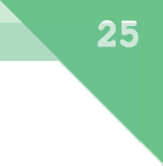IMPORTANT INFORAMATION

The entrance of every subway station is signaled by a big yellow « M ».

Each subway line has a different color to help you find your way inside the stations.

The direction of the line is the name of the last station (terminus).

All the directions and connections are clearly indicated in the subway station, in blue or white signs, on the platform and in the corridors.

**A Caution !** Some stations have several exits (sortie), you need to be look for the name and number indicating the exit.

**GOOD TO KNOW**

Maps of the transport network can be given to you for free at every subway counters, and in the Office du Tourisme (Tourism Office) of Paris. Bigger maps are displayed in the station and at the subway entrance.

The subway runs everyday, including on holidays, between 5:30am and 00:30am, and up to 2am on Fridays and Saturdays.

If you are not a beneficiary of the CMU-C (complementary CMU), you can buy a PASS Navigo Decouverte for 5 € in the subway counters. Remember to stick a photo on it and reload it.

FREE WIFI

Procedures

In most public places in Paris, you can have access to **free wifi** for 2hours, by doing this :

1. Choose the network named **PARIS_WI-FI_**

(usually followed by a number)

2. **Open your browser**; a form will appear that you have to fill in You can renew the process to benefit for two more hours.

**Fast food shops** usually have free wifi that you can access from the outside. (McDonald's, KFC, Burger King...).

A **Be careful !** In Train Station (especially Gare de 1'Est and Gare du Nord) there is a heavy police presence.

BUY A PHONE

You can buy a mobile phone for 10€ in big shops like FNAC.

CHARGING YOUR PHONE

Every **bus stop** in Paris has a USB plug, on the side of the light panels, where the maps are.

DRINKING  
WATER

You can find FREE drinking water in different places in Paris :

• TAPS behind and inside all public toilets.

• “WALLACE” FOUNTAINS. They are dark green fountains that look like statues

A NON-DRINKING WATER will be indicated by a sign saying «EAU NON POTABLE» or «NE PAS BOIRE» (“DO NOT DRINK”).

***page 28***

***page 38***

***page 42***

***page 44***

Applying for reconsideration (reexamen)

If you have been granted a refugee status

Your social rights

***page 46 page 47 page 48 page 50 page 50 page 50***

Domiciliation

Financial benefits

Access to health

Access to housing Enrolling children in school Employment

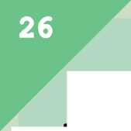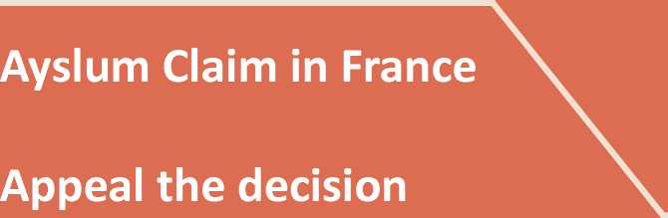

**Asylum claim in France  
in 4 steps**

**The following information takes into account the modifications since the law agreed on September 10th 2018 .**

**Make sure to go to a Free Legal Aid structure (see pages 8-9).**

**The 4 steps for your asylum claim in France are :**

1st Step - SPADA appointment

**Asking for asylum in France is a long and difficult process.**

You may have to wait several days to register at the prefecture.

If your file is processed using the Dublin procedure (see page 33), you will have to wait at least an additional 6 months.

**1st step - The SPADA appointment** pages 29

**2nd step - The appointment with the prefecture** page 30

**3rd step - The different asylum procedures** page 32

**4th step - The OFPRA file and interview** page 34

**Unaccompanied minor (under 18)**

Go to the **DEMIE** (see page 7) to be recognized as unaccompanied minor.

This will grant you the protection of the Child Social Services (*Aide*

*Sociale a I'Enfance)* until you turn 18

(housing, education, healthcare).

**You can still ask for asylum** and make an appointment at the SPADA.

However, if you wish to ask for asylum, you must go through a specific procedure, so be sure to ask help from specialised associations (see pages 7-9)

**As soon as you arrive in France** you must go to a **SPADA** reception centre. These centres are the first reception points for all asylum seekers.

You must go there as soon as possible on your arrival in France to make your asylum application.

A In Paris and Ile-de-France It is mandatory to call this number to make an appointment in SPADA (normal local charge) :

01 42 500 900

You can call from **Monday to Friday from 9am to 3:30pm.** (you are no longer allowed to queue for an appointment).

If no-one answers when you call, keep a record of your call history in your phone so you can prove you tried making an appointment several times.

When you call, wait for the language options, so you can choose yours.

There is a SPADA in every region (Paris, Bobigny, Nanterre...).

Even if you call in Paris, you may receive an appointment somewhere else than Paris. At the end of your call, you will receive a confirmation text message with the date, time and address of the SPADA appointment.

**FAMILIES : go to the SPADA with EVERY MEMBER OF THE FAMILY**, including those who have already been granted asylum in France.

***In the SPADA an officer will:***

1. **Give you information about asylum in France** and **ask for information about yourself**. You will have to give :

* Personal information (name, age...)
* Your date of departure from your country and date of arrival in France. BEWARE if you say you entered the French territory more than 90 days ago, your

file will be processed with the «fast-track procedure», which is not favourable.

* The itinerary you took in order to arrive in France.

• The language you wish to use during the entire asylum procedure.

1. **ask you to fill in your information on the computer in their office.**

This information will be shared with the prefecture. Any false information might lead to your file being processed using the so-called but unfavourable «fast-track procedure». (see page 32)

1. Give you **a “convocation” letter to go to the “one-stop service”** (GUDA). At the one-stop service, you will be able to register your asylum application.

**All the information you need will be indicated on your letter registering your obligatory appointment** (your «convocation» letter) **at the GUDA** (*Guichet Unique pour Demandeurs d'Asile*- Single counter for asylum seekers): Address, date and time of your appointment.

2nd Step

Appointment at the Prefecture

At the GUDA, you will find :

1. The **Prefecture** couner to register your asylum claim,
2. The **OFII** counter which will evaluate your vulnerability during an interview (accommodation and medical situation)

**Be there on time!** If you arrive late at your appointment, you will not be accepted.

Be aware you might spend half a day to a whole day there.

You will be given documents by the Prefecture and the OFII.

**DO NOT LOSE THESE DOCUMENTS**. Take photos, photocopy them and be sure to keep copies (paper and digital) in various places.

***What to do when I arrive at the «one stop service» (GUDA) ?***

1. ***Go to the prefecture counter to register your asylum claim.***

*An officer will :*

• take your **fingerprints**,

* check whether you have already applied for asylum in France or in another country of the European Union.
* ask you to choose the **language you want to speak throughout the whole procedure.** It will be very difficult to change this language one the procedure has started, unless you wish to speak in French.
* give you a booklet to guide you through the procedure in your native language,
* give you an **attestation of asylum application** *(recepisse)* stating which one of these procedures you will be going through : **Normal procedure, Fast track procedure** or **Dublin procedure** (pages 32-33)

is **very important** to understand the difference between these three procedures as the examination of your asylum claim will change (delay and quality of your file review) particularly in the CNDA!

1. ***Then go to the Offi's counter***

What is the OFII ?

**lllllllllllllllllllllllllllllllllllllllllllllllllllllllllllllllllllllllllllllllllllllllllllllllllllllllllllllllllllllllllllllllllllllllllllllllllllllllllllllllllllll**

***Office Frangais d'lmmigration et d'Integration (French Office for Immigration and Integration.)***

***The OFII is responsible for the reception of asylum seekers in France and for accompanying them throughout the procedure of their asylum application (financial aid and housing)***

*An officer will :*

* Ask you about your **personal situatio**n to see if you have specific needs.
* Give you a form called **«Offer of support from the national reception centre»** *(Offre de prise en charge au titre du dispositif national d'accueil)* offering aid from the OFII. Sign the form by checking the box indicating **« Oui, j'accepte de beneficier des conditions materielles d'accueil »** (Yes, I agree to accept conditions)

**A** If you do not agree to this form or do not wish to be granted accomodation, you will not be able to benefit from the financial aid (ADA) : it's a «package» deal. However, be aware that this might involve you being sent to another region in France than the one where you asked for asylum. In that case you must arrive there within 5 days.

If you refuse to go, you no longer be entitled to accomodation and financial aid (ADA).

1. ***Getting a registrated postal address at a SPADA (domiciliation)***

After your appointment with the «one- stop service» (GUDA), you will have to **return to the SPADA to get a registered postal address (domiciliation)**

What is domiciliation ?

**lllllllllllllllllllllllllllllllllllllllllllllllllllllllllllllllllllllllllllllllllllllllllllllllllllllllllllllllllllllllllllllllllllllllllllllllllllllllllllllll**

***In order to carry out all their administrative procedures, asylum seekers need a registered address. This allows the person to receive their mail from the French administrations like OFPRA or CNDA and access their rights.***

***The domiciliation will only be valid during the period of your procedure***

The SPADA is the association which made your appointment at the GUDA.

From the moment this association has given you a registered postal address, you will benefit from their social and legal support (health insurrance, emergency housing, transportation reduction prices, asylum application support...)

1. NORMAL PROCEDURE

3rd Step - The asylum procedures

Your next steps of your procedure now depend on the procedure category you have been placed in by GUDA. The possible three procedures are normal, Fast-track, or Dublin procedure

Your asylum request will be examined in the normal way by the OFPRA *(Office*

*Francois de Protection des Refugies et Apatrides* - French Office for the Protection of Asylum Seekers and Stateless Persons)

You are entitled to the specific social rights for asylum seekers (social security...), financial and housing assisistance (Depending on your agreement to the OFII's benefit form, see page 31)

At the end of your appointment at the «one-stop service» (GUDA) , you will have been given an asylum application file : **the OFPRA file.**

**Ask a specialised association and read page 35 carefully to fill in this file correctly.**

Once you have carefully filled in the file, send it to the OFPRA **within 21 days.**

If your file is complete, the OFPRA will send you a registration letter. It will enable you to renew your asylum claim attestation for 9 months

**A CAUTION!** Renewing your attestation of asylum application can take a few days, be sure to go to the prefecture a few days before the expiration date. If your attestation is expired, you run the risk of getting arrested during an identity check (see page 21)

1. FAST-TRACK PROCEDURE

The examination delays will be shorter. Depending on your situation you may not be able to benefit from material help (financial support and accommodation).

Possible reasons why the prefecture can decide to process your file in a Fast-Track Procedure :

* If you refuse to have your fingerprints taken by the prefecture, or if your fingerprints cannot be read,
* If you hid or gave false information about yourself or your journey,
* If you have received an order to leave the French territory (OQTF),
* If you had already applied for asylum and you are applying for a reconsideration of your file (see page 42),
* If you filed your application more than 90 days (3 months) after your arrival in France and your justification has been refused : the Prefecture will consider you are not in an urgent situation,
* If you are a national of one of the following countries : Albania, Armenia, Benin, Bosnia, Herzegovina, Cape Verde, Ghana, Georgia, India, Kosovo, Macedonia, Mauritius, Moldavia, Mongolia, Montenegro, Senegal, Serbia.

The Fast-Track Procedure enables you to claim for asylum but offers fewer guarantees than the Normal Procedure, especially in the case of appeal through the CNDA (see page 38).

**This procedure is not favorable to the asylum seeker.**

The Prefecture will give you a document detailing the reasons why your application was sent to a fast-track procedure. **Ask for this document if you don't get it : you will need it for your OFPRA file** (see below)

At the end of your appointment at the «one-stop service» (GUDA) , you will have been given an asylum application file : **the OFPRA file.**

**Ask a specialised association (see page 8-9) and go to page 35 of this guide to fill in this file correctly.**

Once you have carefully filled in the file, send it to the OFPRA **within 21 days** (see page 35)**.**

**/\ Be sure to include the document given by the Prefecture explaining why you were placed in Fast-Track Procedure** If you are renewing your asylum application attestation *(recepisse),* follow the advice given for the normal procedure (see page 32)

**If you disagree with the reasons you were place in the Fast-Track Procedure or that you are in a perticularly vulnerable situation, asked to be placed in Normal Procedure.**

The OFPRA is in capacity of changing the procedure in which your file was placed in. Indicate the reasons you should be place in a normal procedure in your story or during the interwiew (see pages 34-37). If OFPRA refuses, then you must renew your request to the CNDA.

1. DUBLIN PROCEDURE

If the Prefecture decides to process your file using the Dublin Procedure, it means that they found proof that you passed through another European country (fingerprints or visa). In this case, the Prefecture cannot register your asylum application in France.

The Prefecture will therefore ask that country to take you back in order to examine your asylum application there. While you wait for the county's answer, you are allowed to stay in France and should be granted asylum seekers assistance program such as the asylum seekers allocation (ADA) and social health insurance (PUMA).

It is possible to appeal your transfer and ask for France to be responsible for your asylum application. Your chances to win the appeal depend on your situation (health, family, countries through which you have been through...) but they are generally slim.

A If you lose the appeal, you will have to wait longer (several months) to be able to apply for asylum in France.

If you do not get transferred to the first country that registered your fingerprints within 6 to 18 months following your registration at the french prefecture, France should normaly be in charge of your asylum application.

In all cases, **go to a Free Legal Aid office as soon as possible** to get extra information about your specific situation in the Dublin Procedure (see page 8- 9).

What is the OFPRA ?

4th Step - OFPRA file and interview

II III Illi III Illi Illi III Illi III Illi III Illi III Illi Illi III Illi III Illi III Illi III Illi III Illi Illi III Illi III Illi III Illi III Illi Illi III Illi III Illi III Illi III Illi III Illi Illi III Illi III Illi III Illi III II

***L'Office Fran^ais de Protection des Refugies et Apatrides (French Office for the Protection of Refugees and Stateless People)***

***It is a public institution responsible for reviewing the asylum applications and taking their decision to grant (or not) the International protection. The decision taken by the OFPRA can then only be reconsidered by appeal before the National Court for Asylum (CNDA - see page 38).***

The two important parts of your application to the OFPRA application are : your **OFRA file** and the **interview**.

1. **The OFPRA file *(dossier OFPRA)*** was given to you by the prefecture at the «one-stop service» (GUDA), ( 2nd step

- see page 30). You will fill it in by writing your story in French and all your personal information.

1. **The interview** at the OFPRA is the most important part of your asylum application.You will be able to talk face to face with an OFPRA protection officer to explain the reasons you left your country and what you fear if you go back.

**The OFPRA decision depends**

**on the file and the interview. Read carefully the next pages to fill in your file and prepare your interview.**

Even though the OFPRA protection officer will ask you to explain, during the interview, why you are afraid of going back to your country, your written story is essential in order to give those reasons in detail, and show that they are relevant to the ‘refugee definition' as outlined in the Geneva Convention. As a consequence, it is very important to provide **precise, detailed, accurate and consistent written information** in the file.

The officer will make the decision by taking into account the overall situation in your country and the particular reasons for your fear. However, the decision depends a lot, on your story and the information that you give during your interview!

**We highly recommend that you read carefully the information provided in this guide about the preparation of your file and about the interview.**

1. THE OFPRA FILE

**You must send the OFPRA file to the OFPRA within 21 days !**

Your story must convince the OFPRA you really are in danger in your country and that you fear persecution, torture or death if you return.

We therefore highly recommend you get help from a specialzed association or from a lawyer to write your story.

**TIP .** Keep copies of your documents. Take photos of all your documents with your phone and contact associations to photocopie the whole file.

* ***How to fill in the OFPRA file?***

**1.** It must be written in French,

1. You must sign the file,
2. It should include the following documents :

* **Two official identity photos**

**•** A copy of your **certificate of asylum application** *(recepisse)*

**•** Your **ID card or passport** (original) if you have one.

1. Fill in your **personal information** as well as your family's information (name, date and place of birth...)
2. Indicate the **language** you wish to use for the interview (see page 36),
3. Write your **story** in French indicating all the reasons why you left your country to ask for asylum in France. It is the first way to let the OFPRA know about your fears in detail so give precise and coherant information. It must include names of people and places as well as specific dates. Do not hesitate to add **material evidence** (photos, IDs...) to back up your story and testify the persicutions you went through.

**We highly advise you not to add fake elements or to pay non­professional people to translate your story.** This could be very harmful for your asylum application. Specialized associations can help you for FREE (see pages 8-9).

**If have made any errors in your story,** you can ask to correct them during the interview.

* ***I need help with my OFPRA file***

You can ask the **SPADA \*** to help you fill in the file and write in French.

(* The SPADA is the organisation that can give you a postal address if you don't have a place to live, see pages 8-9).

Even if you get help from another organization or a lawyer, **read carefully the information** given by this guide regarding the OFPRA file : The information you give in your file is very important for your asylum application.

* ***How and when to send the file ?***

You must send to file to the OFPRA within 21 days, from the date you got it at the prefecture, to the following address:

**OFPRA  
201, Rue Carnot  
94120 Fontenay-sous-Bois**

Send the file as a **registered letter with acknowledgment of receipt** (*lettre recommandee avec accuse de reception*) from the Post Office to prove you have sent the file.

OR deposit your file at the OFPRA (but you will not immedialty be given a receipt proving your file deposit - *depot de dossier).*

**We advise you to keep copies of all your documents and the proof you sent your file.**

1. THE INTERVIEW

The interview with the OFPRA is the most important part of your asylum application.

You should receive a letter giving you the time and place of your obligatory appointment for the interview with a protection officer from the OFPRA. It should arrive at the same time as the letter confirming the regstration of your asylum application. **Check for any letters at your registered postal address (domiciliation) as often as possible!** The date, hour and details of the interview will be written in the letter. **You should make there on time the day of the interview.**

/^KThe OFPRA can now contact you by email or text message. If you gave your email address and phone number to the administration, be sure to check your emails and phone regularly.

*•* ***Who will be at the interview ?***

* A **protection officer from the OFPRA** (This person is not from the police.)
* An **interpreter** if you do not speak French. Double-check they really speak your language correctly. If they don't speak your language, **you should tell the protection officer.**

You can ask for the presence of **a lawyer or a legally authorized representitive from an association** as silent witness. They will be authorized to speak at the end of the interview.

Any authorized person is obliged to agree that they are unbiased and any information stays confidential.

* ***What happens during the interview ?***

The protection officer will ask questions based on the information you gave in your OFPRA file. However, everything you say during the interview will be more important than what you wrote in the file for the final decision.

1. The **first part** of the interview will be about your **civil situation** : the protection officer will ask you about your identity and your family situation. This is to confirm the information is correct and complete and to check the spelling of names and not to forget anyone.
2. The **second part** will be about **your story and your personal fears**. You will be able to talk about the events that led you to leave your country. You will be asked for further details about the events (dates, places...). You must give precise answers and insist on what happened to you personnally.
3. At the **end of the interview,** you will be asked to explain **what you presently fear** if you return to your country.

* ***How to prepare for the interview?***

**Your interview is confidential** : you can speak freely. It is important to speak as naturally and spontaniously as possible. **Don't learn your story off by heart.** Try to detail what you went through trying to remember the chronological order of events, dates, places, people and what role they had : everything that could help the protection officer understand your story.

**Stick to the facts** : if you don't know something or if you have forgotten, say so! If you don't understand a question or if you have any doubts, don't hesitate to let the protection officer know.

**If you suffer from memory loss**, that you regularly have nightmares and that reliving these events is very difficult, let the protection officer know about your situation. You may be suffering from post- traumatic stress. You can get help from a doctor to talk about it and get a medical certificate to deliver to the OFPRA (see page 12-13)

***• How and when will I receive the decision ?***

**The OFPRA usually takes a decision within 3 to 4 months** though it may take longer than expected. If this is the case, the OFPRA will send you a letter to inform you of the delay. You might be called for a second interview.

The OFPRA should send you the **final decision** by registered mail to your address.

**Check your letters in your domiciliation centre as often as possible!** (if possible, once a week).

The postman will leave a notification slip («Avis de passage»). You should check the Post Office branch address on the notification slip and you must go that address within 15 days with the notification slip and your certificate of asylum seeker (as proof of identity). It is very important that you collect your letter within 15 days of reception of the notification.

**/|\The OFPRA may send you their deicision by e-mail.** Check your e-mails regularly as the time and date you were notified is very important if you have to appeal !

***• What to do when I have received the decision from the OFPRA ?***

The OFPRA will decide if France must protect you : you can be granted with a refugee status or a subsidiary protection; your application can also be rejected.

1. **If the OFPRA grants you the refugee status (statut de refugie) :**

Go to the prefecture with the approval letter to get a renewable residence permit valid for 10 years

1. **If the OFPRA grants you the subsidiary protection (protection subsidiaire) :**

Go to the prefecture to get a residence permit valid for 4 years and then a renewable residence permit valid for 10 years. You can appeal this decision (see next pages, same process). Appealing the decision won't make you lose the subsidiary protection.

***If you have been granted the refugee status or subsidary protection read pages 44 - 45 for your next steps.***

1. **If the OFPRA rejects your application:** You can appeal the decision before the National Court for Asylum (CNDA) (see next pages).

**A** If you have been put into a **Fast-Track procedure**, you might lose you residence permit once the OFPRA has rejected your application. You might be sent back to your country, even during the CNDA appeal. In that case, **go straight to a free legal aid office for advice** (see pages 8-9)

What is the CNDA ?

**Appealing the OFPRA decision to the CNDA**

If the OFPRA has rejected you asylum application you can **appeal that decision to the CNDA.**

***How to appeal to the***

***CNDA ?***

The appeal must be presented as a letter, accompanied by enclosed documents if necessary, and must be written in French. In this letter, some important elements must be written:

• **Your civil status and personal information** (name, date and place of birth, nationality, address...) • **Arguments to refute elements of the OFPRA's decision you want to contest.** Explain clearly the reasons why you think OFPRA was wrong about your case.

The appeal must reach in CNDA **within one month from the date you received the decision from OFPRA**; this means within one month from the day you picked up the letter from the Post-Office, or the date written on the postman's non-delivery notice (*avis de passage*) in your domiciliation centre. If you received it by email, it will be day you read it (or 15 days after reception of the mail giving the decision).

**Appealing to the CNDA isn't that easy.**

We advise you to ask for help from specialized associations (see pages 8-9) or from a lawyer (see page 39).

You have 3 options :

1. Ask for a **free lawyer** to help you by applying for “legal aid” (*aide juridictionnelle*), 2. Hire a **private lawyer**,

3. go through the appeal **by yourself** (highly unrecommended)

**lllllllllllllllllllllllllllllllllllllllllllllllllllllllllllllllllllllllllllllllllllllllllllllllllllllllllllllllllllllllllllllllllllllllllllllllllllllllllllllllllllllll**

***Cour Nationale du Droit d'Asile The National Court for Asylum is an administrative jurisdiction.***

***It's Judges review any appeal you can make against OFPRA's decision to reject your asylum application. They examine closely the arguments presented by both parties (the OFPRA and the asylum seeker), and then take their decision. The CNDA can cancel the OFPRA's decision and grant the asylum seeker the status of refugee or the subsidiary protection.***

***They can also reject the appeal: in this case the asylum seeker is denied the right to benefit from asylum in France.***

1. A free lawyer

Be careful, you have very little time to get legal aid from a free lawyer : You should apply **within 15 days** of receiving the rejection letter from OFPRA.

Since a recent new law passed (10th September 2018), you only now have 15 days to officially request free legal aid otherwise you will have to prepare your defense by yourself. This is not recommended.

If you applied for legal aid, the lawyer (who will receive a copy of your letters) will assist you through all the procedures linked to the appeal.

Two ways of applying for a free lawyer

* **Get help from the SPADA or from a specialized association :**

Go to the SPADA or a legal aid office for help (see pages 8-9)

* **Ask for a free lawyer «legal aid» by yourself :**

Write a letter with your signature, specifying your civil status, your OFPRA file number and a copy of the OFPRA's decision.

Send the letter as a **registered letter with acknowledgment of receipt** (like the OFPRA file) to this address :

**Cour nationale du droit d'asile  
Bureau d'aide juridictionnelle  
35 rue Cuvier,  
93558 Montreuil Cedex**

Or by **fax : 01 48 18 43 11**

Or you can drop off your letter at the address yourself.

If you find a lawyer in another way, he/she must send a letter to the CNDA to let them know he/she's in charge of your file.

If you apply for a free lawyer within 15 days after receiving your letter of rejection by the OFPRA, **the one- month period for filing the appeal will be interrupted until you are granted a lawyer.**

You will receive two letters within 15 days : • The registration of your application, **•** The agreement of your application with the name and address of your lawyer.

**Once you've receive this letter, your lawyer will have a very short time to appeal!**

Your lawyer will need to meet you and listen to your story to prepare your case against the OFPRA's decision.

**Get in contact with your lawyer as soon as possible!**

Lawyers are usually very busy but don't hesitate to make an appointment. If you cannot make an appointment with your lawyer, ask for the help of an association. (see page 8-9)

1. A private lawyer

You will have to find and pay this private lawyer by yourself.

With the help of your lawyer, you must send your appeal to the CNDA within one month after the reception of the OFPRA's rejection.

If you cannot make an appointment with the lawyer you've paid, ask for the help of an association. (see page 8-9)

1. Appeal without a lawyer

This is not recommended. You will be defending your case to the CNDA without the help of a lawyer. If you wish to appeal and defend your case by yourself, read the previous information to know the important elements of an appeal.

***What happens after I have sent my appeal ?***

The CNDA processes your file.

• You will receive your appeal registration letter from the CNDA (*lettre enregistrement du recours a la CNDA),* proving that your appeal has been registered.

• You will then receive a convocation letter to attend the public hearing at the CNDA.

(convocation a la CNDA)

A if your case doesn't a good enough defense to contest the OFPRA decision, the CNDA can reject your appeal without a thorough review or a hearing.

(It is called *decision de rejet par ordonnance CNDA*).

***The hearing*** takes place within the CNDA's building (35 rue Cuvier in Montreuil, in Paris's suburb). It is very important for you to attend it. Note that these hearings are public, so anybody can attend it.

You can attend someone else's hearing to help you prepare your own hearing.

During the hearing, you will sit in front of a court made up of three people. Your lawyer will sit on your right side, and your interpreter on your left side.

If your asylum application is processed in a fast-track procedure, the court will not be made up by three people but by one single judge.

On the day of the hearing, you can ask your lawyer to request a hearing without any public.

The hearing runs as follows :

1. **The *rapporteur*** explains your case,
2. **The judge(s)** ask you questions in order to clarify some points in your story. This part is very important. Speak as naturally an spontaniously as possible, answering as precisely as possible the questions asked.(See page 36 with our advices for the OFPRA interview)

Your lawyer will not be able to help you during that part : you know your story much better that he/she does !

1. Finally, **your lawyer** will speak and defend your asylum application, insisting on some important elements of your story and criticizing the OFPRA's decision.

You will receive the CNDA's decision within the next three weeks by registred letter. The decision will also be displayed at the CNDA on a date specified the day of the hearing.

***What should I do once I have received the CNDA's decision ?***

You will receive the CNDA's final decision within the next three weeks by registred letter to your address. **Check your letters at least once a week!**

The CNDA can either decide to cancel the OFPRA decision, granting you the refugee status or subsidiary protection, or can refuse your asylum application.

* If you have been granted the r**efugee status or subsidary protection** read pages 44-45, for information about how to go through the next steps.
* **If the CNDA refuses to grant you protection**, you have very little possibilities left :
* You can appeal in front of the Board of State *(Conseil d'Etat)* but the conditions are very strict and very rare : This appeal only concerns problems linked to the procedure, not the information in your file;
* You can also ask to have your file re-examined but you must have more facts added to your situation that haven't yet been studied by the OFPRA and the CNDA during your asylum application. (See page 42)

If the CNDA refused to grant you protecture, you will lose your right to stay on French territory. You can get arrested and sent back to your country. Go to a free legal aid office to ask for advice (see pages 8-9) and read carefully pages 21-23 «In case you get arrested» to know your rights.

**Applying for you case  
to be reconsidered  
*(reexamen)***

If you hear about new events worsening your security in your country, you can apply for reconsideration of your asylum application to the OFPRA. There are no specific delays to apply for reconsideration. The only condition is to have new facts confirming the threats against you if you return to your country.

**Be sure to understand what defines a new fact**

If you apply for reconsideration with an file that does not meet the criteria described below, your application will be rejected without an interview.

***What is a new fact?***

It is an event indicating that you may still fear persecution or serious threats, meaning those threats are still going on.

**A fact is new if it occurred after the final rejection of your previous asylum application.**

Therefore, a fact is new if it happened: • After the date of the decision of the National Court of Asylum (CNDA)

• After the date of the decision of OFPRA (If you did not appeal to the CNDA)

**Note that :** If the event occurred before the decision of rejection from the OFPRA or the CNDA, the fact is considered as new if you can prove that you did not know about it at the time of the decision of rejection. or that you couldn't talk about the event during you first application.

**Examples** of events that can be considered as new facts **if they have not been mentioned before to the OFPRA or CNDA**:

* The evolution of the political and/or security situation in the country if it has an impact on your personal situation.
* The grant of protection status to a relative whose fears of persecution are related to your own situation.

New evidence is not a new fact.

Your reconsideration will not be accepted if the element that you add only confirms your previous oral or written statements.

**Examples:**

* A membership certificate from a political party is not new evidence if you had previously mentioned your membership to this party.
* A newspaper article or a letter from a lawyer mentioning facts that had already been considered in your previous application will only be considered as simple evidence for previous facts.

A new element is not necessarily a written document. It can be an event that you can describe in oral statements.

In that case, you will have to be very precise about your statement (dates, places, names...) to recount the event.

**IMPORTANT TO KNOW**

Even if your fact is conseidered as

«new», il will not automatically ensure a protection.

Do not add any documents in your file without explaining how you found them and why you didn't present them during your first asylum application.

It is important to know that even though some documents contain new facts, the «applications for reconsideration» are often rejected by OFPRA and CNDA as they are doubtful about their authenticity.

***How apply for your case reconsidered ? x***

**Just as for your first asylum application, the application for reconsideration is handled by the OFPRA and the CNDA.**

First of all you must go to the SPADA to make an appointment with the prefecture to hand in your application for reconsideration.

You should normally go the the SPADA in the same region of the prefecture where you made your first application.

In Paris and Tle-de-France, you can call the OFII number (01 42 500 900) and specify you want to apply for reconsideration.

At the prefecture you will be given an attestation for you asylum application and a file for asylum application (pink). Your application will automatically be processed in a fast-track procedure. The examination delays will be very short.

Write your story with the new

facts and to ask advice from a specialized association before going to the prefecture.

**You only have 8 days to send your file to the OFPRA.**

If your application for reconsideration is declared invalid by OFPRA, you can appeal to the CNDA to contest this decision.

If the application is declared valid but, after the re-examination, is rejected by the OFPRA, you can also appeal to the CNDA (see page 38)

**In the case you have  
been granted protection**

You will find more information on the online page « **le guide du refugie** » translated in English, Russian and Arabic :

**<https://leguidedurefugie.com/>**

The **refugee status,** the **subsidiary protection** or the **stateless status** granted by the OFPRA or the CNDA enables you to :

* be protected by the French State,
* get a residence permit and

- have the rights granted to the French population.



**If you are a resident of a SPADA (ex-**

**PADA), you are allowed to get a 6 month assistance from the SPADA as from the day you receive the decision granting you protection.**

**Warn the team so they can help you with the next steps!**

As soon as you receive the decision, go to the prefecture with a residence attestation and the decision to be able to obtain an **attestation *(recepisse)****.* This attestation *(recepisse)* is a provisional document attesting the international protection recognition (reconnaissance de protection internationale). It will enable you to start the procedure while you wait for you residence card.

***What are my rights?***

* The OFPRA will deliver your **civil state documents** (*documents d'etat civil*). They are documents in your name that are recognized by French administration (birth certificate, wedding certificate...). You have no legal right to contact your own country's administration, otherwise you will lose your State protection. These civil state documents will enable you to obtain you **residence card** delivered by the prefecture.
* You will be granted **travel documents** to travel to other countries, except to your home country.
* You can start your **family reunification** procedure to enable you family members to join you (Warning : this is a rather long procedure which can only be done in special circumstances)
* As soon as you receive the decision from the OFPRA or the CNDA, you can «open your rights» to benefit from **social and family benefits** (RSA, social housing application.)
* **You are allowed to work in France.**

These first steps may seem complicated, you can **get help from various organisations:**

* The **SPADA reception centre or housing centre** you were living in during the procedure are obliged to help you «open your rights», find a new address and housing.
* The **communal social action centr**e (*centre communal d'action social* - CCAS) of the town you have been living in : You can make an appointment with a social worker who will assist you with your financial and employment procedure (CAF and Pole Emploi) as well as your social housing application file.

• A **legal aid association** for refugees (see pages 8-9)



***y* Your social rights**

Domiciliation

Having an administrative address in France is a necessary step for you to benefit from your social rights. A domiciliation is a postal address where you can receive letters from French administrative services. It is not necessarily the same address of where you actually live.

• For asylum seekers

When you start your asylum application in France, the SPADA assisting you must open a domiciliation for you. As soon as you go through the one-stop service (GUDA) you will obtain an appointment to get an address.

This is only possible if you are an asylum seeker.

**WARNING, only the domiciliation certified by the prefecture will be acceppted for the renewal of certificate of asylum seeker *(recepisse}.***

Your domiciliation can be :

• a SPADA

• the housing centre you live in

• your own address if one of your relatives (parent, brother or sister) is a tenant there. A friend's housing attestation will not be accepted!

**If you don't have an address go the your region's OFII to get in contact with the SPADA that will be able to help you.**

*•* For refugees

People who were granted the international protection (refugee status, subsidiary protection or stateless status) have a right to keep their domiciliation and to be assisted by the SPADA for 6 extra months after having received the decision. You will however be encouraged to quickly start searching for a new address before your domiciliation in the SPADA ends. You can go to the social action communal centre (CCAS) of the town you've lived in for the past 3 months : You will be provided with services from a social worker. You can also ask assistance from an association (see following information)

• For other situations

If you are a refugee, asylum seeker or if you don't have any papers in France, in a particular situation, you can ask an association for assistance and potentially domiciliation. This address will enable you to carry out your procedure. If the association cannot give you domiciliation, it will however advise you according to your situation to help you find domiciliation through an adapted organisartion.

**Dom'asile - Cimade**

**A** 18 bis boulevard Arago, 75013 Paris

® Gobelins (line **7** )

Q Monday 5pm-7pm, Saturday 11am-1pm

**Dom'asile - Foyer Grenelle**

**A** 17 rue de I'Avre 75015 Paris

® La Motte Piquet Grenelle (line **6** / **8** )

Q Tuesday and Wednesday at 9:30am

**Dom'asile Cedre - Secours Catholique** (For those who get the refugee status) # 23 boulevard de la commanderie, 75019 Paris ® Porte de la Villette (line **7** ) **G)** Monday, Tuesday, Thursday : from 8:30am to 5pm.

**G**

**Financial benefits**

© Dom'Asile

At the GUDA, the OFII offers asylum seekers the possibility to benefit from its help: this help consists in a housing and a financial benfits. It is called «l'offre de prise en charge au titre du dispositif national d'accueil» (The offer of care in conformance with the national plan of reception).

To benefit from it, you need to sign the form the OFII will give you, saying you accept the material conditions of reception *(Conditions materielles d'accueil* )

• If you accept and the OFII can provide you with accommodation or that you indicate you are being accommodated for free, you will receive a financial support of 6.80€/day (ADA).

• If you accept and the OFII doesn't provide you with a housing, 7,4€/day will be added to the financial benefit you receive.

• If you have a husband, a wife or children with you in France, an additional sum of 3,4€/day will be added to your financial bene.

The OFII will provide you with an ADA debit card, specifically designed for asylum seekers. This card will allow you to receive your financial benefits each month. **You can only withdraw money 5 times each month with this debit card**. It is therefore important for you to have a Livret A, so you are not so limited with your withdrawals.

You can ask the OFII to send your financial benefits directly onto you bank account called Livret A. See page 24 to open a bank accout.

You will receive your ADA at the begining of each month as long as your asylum application in being processed.

**In case of loss or robbery of your ADA withdrawal card, call this number to make an ‘opposition' (so that the card no longer works): 0811 041 041**

If you are not receiving your ADA, go to the SPADA or in a legal aid centre to get help. As the OFII is in charge of your financial support, you can also directly contact your region's OFII .

Access to free health support

© Refugies Bienvenue

© Ministere de I'Interieur

Emergency care

While you are waiting to benefit from the sociaI protection offered to asyIum seekers through the affiIiation to heaIth insurance you can go to the Free MedicaI Access Points **(Permanences d'Acces aux Soins de Sante -PASS)** within the hospitals (see page 10-11). You wiII be taken care of by doctors and have access to free medication and treatments.

Furthermore, some associations offer free medical access points for dental, ophthalmologic and psychological care without being insured.

According to your housing area, the «maisons du departement» often offer free maternal and child care ( Protection maternelle et infantile- PMI), ensuring the regular and on-time vaccination of children. There are also centres for family planning and education for women providing information on contraception and pregnancy aftercare. You can benefit from these services even before your affiliation to PUMA.

The Universal Health Protection (PUMA - formerly called CMU)

If you are an asylum seeker that has been in France for 3 or more months, you can benefit from the affiliation to health insurance through the Universal Health Protection (PUMA) and complementary Universal Health Coverage (CMU-C) by presenting the asylum application that is given to you at the one-stop service (GUDA), together with a “declaration of domiciliation” (see First Step page 24) This will allow you to access free medical health care and hospitalisation for you, your spouse and your children.

In order to benefit from the PUMA, you need to apply to the **Caisse primaire d'assurance maladie (CPAM)** of your residential area. In order to complete this application, you can ask for help from the structure hosting you, or the structure in charge of accompanying you throughout the review of your asylum application. You can also always ask for help from associations, communal centres for social actions or hospital social services (see pages 10-11).

In all cases, you need to be able to show evidence of your regular stay in France, by showing :

* a proof of convocation / appointment with the prefecture
* a receipt confirming the asylum application or a receipt from OFPRA accompanied by a “declaration of domiciliation”

The access to the basic PUMA **is permanent and immediate**. But the complementary CMU (CMU-C) is valid for one year only. It is therefore necessary to apply for **the renewal of the rights each year to benefit of the complementary CMU (CMU-C).**

CPAM used to be able to attribute you a social security number and provide you with an electronic health card called «Carte Vitale». However, at present, the «Carte Vitale» can only be given to people who have been granted the refugee status or the subsidiary protection.

State Medical Aid *(Aide medicale d'Etat* -AME)

Like the PUMA, the AME allows the asylum seeker to receive medical care in city medical facilities.

The AME cover 100% of all medical and hospital treatments it approves of. The AME can be obtained if you have:

* Irregular stay (not having valid residence permit, asylum application receipt, nor documents showing the proceeding to obtain a valid residence permit )
* Regular stay (having resided in France for at least three uninterrupted months )
* Resources (they can't go beyond a certain threshold)

***Application procedure:***

you must fill ***the formulaire cerfa n°11573*05,*** which contains instructions and tells you which documents you need to provide, depending on your situation

The dossier needs to be deposited or sent to the *Caisse Primaire d'Assurance Maladie* (CPAM), or to one of the following institutions: health insurance organizations, communal centres of social actions, health and sanitary services of the concerned area, health facilities.

These institutions can help you assemble the dossier; they then forward it to the CPAM, with your agreement, within 8 days.

The CPAM will inform you of its decision within a maximum delay of 2 months; if the application is accepted, you can obtain your AME card with 1 year validity, starting from the beginning of the application procedure (the renewal is not automatic, the dossier needs to be filled again 2 months before the expiry date of the AME card).

Access to accomodation benefits

School enrollment

for children

© Refugies Bienvenue

At the moment of registering your application, you will receive an offer from OFII which might allow you, in theory, to obtain a place in a housing centre (CADA, CAO, PRADHA...).

It is important to know that as the centres are full and that not avery asylum seekers will benefit from this service.

For the others, the main solution is to call **115** (emergency line) every day asking for a shelter for the night. It is important to call several times before 6 am, time when the call service becomes active and assigns time slots to call again later in the day. Again, this service does not guarantee a place to sleep.

If the you have accepted the OFII's offer but that no housing centre has been able to host you, you have nonetheless the right to an allocation.

In France, every child under 16 has the right to go to school : your status or the one of your parents does not matter, and the type of housing you're in does not either. School is **free** and nobody can deny a child access to it. You need to ask the city hall (*mairie*) next to where you live and if you encounter difficulties, you should contact a legal aid service (see page 8-9).

Acces to employment

**If you are an asylum seeker and you haven't been provided with accommodation during your asylum procedure,** you can go to a DAY CENTRE for single women, couple, families or single men in order to try to get an accommodation (see page 6).

© Services Publics

As an asylum seeker, from the 1st March 2019, you will only be allowed to start working 6 months after having started your asylum procedure, and only if you do not have yet received an answer from the OFPRA. You need to file a request to the prefecture, to have the authorization to work. You will need to give them a valid work contract, an offer of employment and other documents.

This authorization will only be valid as long as your asylum application attestation *(recepisse)* is valid. This work authorization can be renewed during the whole period you are awaiting the decision from the OFPRA.

Other useful informations

page 52

page 54

page 56

Associations

Facebook groups and

pages

Acronyms (useful words)

page 58 Metro map



NON-MANDATED ORGANIZATIONS

**During your asylum application, you can meet these organizations, associations and collectives:**

MANDATED ORGANIZATIONS

©These organizations receive money from the government to help it implement its policies

LACROIX ROUGE

Association appointed by the town hall to be in charge of the DEMIE (one- stop service for isolated minors) and of several housing centres. They organize "maraudes" (street visits).

EMMAUS

In charge of several housing centres, especially for women and families.

FRANCE TERRE D'ASILE (FTDA)

Association appointed by the State to be in charge of the SPADA (boulevard Ney in the building of the Paris Prefecture). They organize "maraudes" (street visits).

© These organizations have their own objectives and are not carrying out government policy. They are taking actions primarily in favour of migrants, asylum seekers, refugees and people in exile.

BUREAU D'ACCUEIL ET

D'ACCOM PAG N EM ENT DES MIGRANTS (BAAM)

Legal aid for asylum seekers, OFPRA story translations, free French lessons

@ : [www.baamasso.org](http://www.baamasso.org)

Facebook : BAAM

LACHAPELLE DEBOUT !

Activist organisation. Present in administrative detention centres (CRA), defending the rights and freedoms of migrants, organizing actions to support migrants, undocumented people and nomadic populations.

[collectif.lachapelle.debout@gmail.com](mailto:collectif.lachapelle.debout@gmail.com) @ [https://blogs.mediapart.fr/la-chapelle-en- lutte/blog](https://blogs.mediapart.fr/la-chapelle-en-lutte/blog)

Facebook : Collectif La Chapelle Debout

LA CUISINE DES MIGRANTS

Distribution of hot meals

Facebook : La Cuisine des Migrants

MEDECINS DU MONDE

Humanitarian association providing medical aid.

Association helping foreign women former or present victims of violent situation and/ or vulnerability due to their gender.

[association.kali@gmail.com](mailto:association.kali@gmail.com)

@ : <http://associationkali.org/>

Facebook : KALT

LAGAMELLE DEJAURES

Association organizing food and material distributions.

MEDECINS SANS FRONTIERE

(Doctors without Borders)

Humanitarian association providing medical aid.

PARIS D'EXIL

Former Collectif Parisien de Soutien au

Exile.e.s. Activist organisation. Material support, advice, orientation toward more specialized structures and follow-up in terms of legal aid and healthcare @ : [www.parisdexil.org](http://www.parisdexil.org)

Facebook : Paris d'Exil- Collectif parisien de soutien aux exile.e.s

PARIS REFUGEE GROUND SUPPORT

English collective created in September 2016. Night "shift" to provide material support.

Facebook : Paris Refugee Ground Support

SAJE

Help and reception for unacompanied minors. Material help (food, first aid products, health...), advice for minors status procedures, orientation and follow up. info@saje.paris

Facebook : Saje (Soutien et accompagnement des jeunes en exil.

SCIENCESPO REFUGEE HELP

Student association created in August 2015. Support with material distribution, asylum aid, orientations, French lessons, social activities, printing...

Facebook : Sciences Po Refugee Help

@ : [www.refugeehelp.fr](http://www.refugeehelp.fr)

SOLIDARITHE

Distributions of information and tea and coffee

Facebook : Solidarithe

SOLIDARITY MIGRANTS WILSON

Breakfast distribution and, occasionally, packed lunches

Facebook : Solidarite Migrants Wilson

TIMMY

Collective existing since winter 2015 for supporting and following up on foreign isolated minors *(Mineurs Isoles Etrangers* -MIE).

UTOPIA 56

Emergency housing for women and families and long term housing for unaccompanied minors (aged under 18)

Every evening in Porte d'Au bervilliers (7pm) [utopia56.paris@gmail.com](mailto:utopia56.paris@gmail.com)

Facebook group: Utopia Paris et lie de France

@ : [www.utopia56.com](http://www.utopia56.com)

© Some volunteer neighbours also organize "maraudes" (street visits) to bring information, material and food. They also try to help with the needs of those who sleep outside.

FACEBOOK GROUPS/PAGES

**(for information or help):**

BIENVENUE AUX REFUGIE-E-S

This page is about the reception and de­nunciation of the repression of foreigners who have just arrived in Europe.

COMITE DE SOUTIEN DES MIGRANT DE LACHAPELLE

This page was created to give reliable in­formation directly from the source about the struggle of refugees in Paris, and to organize support.

REFUGIES DE LA CHAPELLE EN LUTTE "In support of refugees from the La Cha- pelle district in Paris, victims of State illegalisms, chased and harassed by the forces of disorder".

SOUTIENS AUX EXILES DE GDE ET STALINGRAD

Support to those who sleep outside around Gare de I'Est and Stalingrad. It is a Facebook group to centralize information and requests for support (French classes, orientation, information, translation, printing, etc.)

STUDIES IN FRANCE FOR REFUGEES

This group is for sharing information, experiences and questions concerning the continuation of studies in France for refugees and asylum seekers.

PLATEFORME D'AIDE AUX REFUGIES EN FRANCE

"This Facebook group is intended as a support platform. Everyone can offer help, housing, material goods, food, clothes. In every town and village in France we can act."

Notes :

**ACRONYMS  
(useful words)**

**CADA - (Centre d'accueil des demandeurs d'asile)**

Asylum Seekers Care Centres are accommodation centres for asylum seekers that provides social and legal support.

**ADA - (Allocation pour Demandeur d'Asile)**

Allowance for Asylum Seekers is a financial aid that can be given to adults who are in possession of their certificate of asylum seekers.

**AME - (Aide Medicale d'Etat)**

State Medical Aid which allows foreigners in irregular situation to benefit of free access to healthcare.

**ASE - (Aide Sociale a I'Enfance)**

Child Welfare Services to accommodate and protect foreign unaccompanied minors in France.

**CAES - (Centres d'accueil et d'examen des situations)**

Care and Situation Evaluation Centres are temporary accommodation centres for asylum seekers. They allow individuals in need to find shelters everywhere in France according to the administrative status.

**CAO - (Centre d'Accueil et d'Orientation)**

Care and Orientation Centre is an accommodation centre for asylum seekers

**PUMA-(Protection Universelle Maladie)**

Universal Healthcare Protection (formerly called CMU - Universal Healthcare Coverage) allows individuals with a residence permit to benefit from a free access to healthcare.

**CNDA - (Cour National du Droit d'Asile)**

National Court of Asylum is a court of law that makes it possible to appeal the decision of OFPRA.

**CPAM - (Caisse Primaire d'Assurance Maladie)**

Local Healthcare Insurance Office ensures the refund of healthcare expenses.

**DEMIE- (Dispositif d'Evaluation des Mineurs Isoles etrangers)** Evaluation Device of Foreign Unaccompanied Minor is managed by the Red Cross. It ensures Care, evaluation and orientation to young foreigners. Their role is to determine if they really are minors and if they are allowed to profit from shelter as a child protection right.

**GUDA - (Guichet unique en charge de I'accueil des primo- arrivants)**

Unique Counter in charge of newcomer's care is a place where are gathered the prefecture's and the OFII's services. The prefecture has to register the Asylum application. The OFII receives the individual for an interview and can provide shelter and an allocation to the asylum seekers, as well as facilitate the integration of refugees and return assistance.

**OFPRA - (Office Frangais de Protection des Refugies et Apatrides)**

French Office for the Protection of Refugees and Stateless Persons is a state's service in charge of granting or refusing the refugees status to the asylum seekers.

**OQTF - (Obligation de quitter le territoire frangais)**

Obligation to leave the country is a foreigner's expulsion administrative measure. In case of issue refusal of the residence permit or irregular residence, it forces you to leave France by your own means under a 30-day deadline. In some more limited cases, there is no deadline. An appeal is always possible.

**PASS - (Permanences d'acces aux soins de sante)**

Permanence of Healthcare Access is a place that's available in every hospital that can provide access to a free medical consultation, even for irregular foreigners.

**RSA - (Revenu de solidarity active)**

Active Solidarity Revenue is a financial aid. To obtain it you have to be looking for a job.

**SPADA - (formerly PADA) Structure de Pre-Accueil des Demandeurs d'Asile)**

Structure of pre-care of Asylum Seekers which welcomes the asylum seekers before their passage to the GUDA and supports them in their administrative procedures (OFPRA record).

*Paris*

***ratp.fr***

**L^gende**

J RER: au dels de cette limite, en direction de la banlieue, la tarification depend de la distance. Les tickets t+ ne sont pas valables.

0=0 CD O Correspondances

| } Fin de lignes

en correspondance Pole d'echange multimodal, metro, RER, tramway Liaison urbaine Comptoir-Club

***n Asnieres  
Gennevilliers***

Les Courtilles

Le Luth

sur-Seine

Le Bourget

Delaunay-Belleville

P. Eluard

St-Denis

Guynemer

Denis orte de Paris*

•^13 Saint-Denis-Universite

de Villeneuve la-Garenne

La Noue

des Chanteraines

**,L**

Stade Geo Andre Le Bourget

Gennevilliers

Pontoise

Epinay Orgemont

®® ®@

Timbaud

Le Village

Les Agnettes

Les Gresillons

Gabriel Peri

(§9 RoissyBus 0CDG Aeroport Charles de Gaulle

0

»

Mitry-Claye

Rougemont

Chanteloup

Chanteloup

des Expositions

Porte d'Aubervilliers

Theatre

Gerard Philipe

J

Joffrin

fzglise de Pantin*

Crimee*

Danube

Jaures*

Gare du Nord

HOpital

Mairie des Lilas*

Botzaris

3“- Porte des Lilas

Le Peletier

Couronnes

Goncourt*

Opera*

Gambetta*

du Calvaire

Croix de Chavaux*

Pont Neuf Chatelet

Robespierre

Porte de Montreuil

Vincennes

Nation

Mabillon Odeon*

Reuilly-Diderot

Saint-Sulpice

Montgallet

Luxembourg

■ Montempoivre

Jussieu*

Daumesnil*

Miche

Vavin

Port-Royal

Dugommier

Porte Doree

Bercy

Raspail

Porte de Charenton

Liberte

Creteil-L'Echat

Laplace*

Creteil-Universite

Arcueil-Cachan

Creteil-Prefecture

Mairie d

Adrienne Bolland

Notre-Dame des-Champs

Grands

Boulevards

Maisons-Alfort

Les Juilliottes

Hotel de Ville de La Courneuve

Le Kremlin Bicetre

Villejuif

Leo Lagrange

La Courneuve Aubervilliers

Les Gobelins

Tolbiac

Maison Blanche*Q

Le Vert de Maisons

Lamarck

Caulaincourt*

Fort

d'Aubervilliers

Pierre et Marie Curie

Alexandra

David-Neel

Berault

Villejuif

Paul Vaillant-Couturier

>t-Mande*

Boissy-St-Leger*

Richelieu Drouot* 0

Cite

Universitaire*

Place

Monge

Censier Daubenton*

Aulnay sous- Bois

Quatre Septembre

Bourse Sentier

La Courneuve

8 Mai 1945

Maisons-Alfort Alfortville

Roger Semat'

Baudelaire

Marche de St-Denis

Stade de France Saint-Denis

Chaussee d'Antin La Fayette

O

Stade Poterne

Charlety des Peupliers

Ledru-Rollin*

Faidherbe

Chaligny

Cimetiere Hopital La Courneuve

de Delafontaine Cosmonautes 6 Routes

La Courneuve

**Danton (t)**

Maurice Lachatre

Drancy - Avenir

HOpital Avicenne

Gaston Roulaud

Escadrille Normandie-Niemen

La Ferme

Liberation

HOtel de Ville de Bobigny

Saint-Jacques

Pierre de Geyter Basilique

de St-Der

Strasbourg

Saint-Denis

Chateau

Jacques

Bonsergent

St-Placide*

Duroc*

Rambuteau*

Louis

Republique*

Oberkampf*

Parmentier

E

Fitzgerald

Bobigny-Pantin

Pte de la Villette* Parks

Corentin Cariou

Raymond Queneau ine

Carrefour

Pleyel

Saint-Ouen

Mairie de Saint-Ouen*

Garibaldi

O

iCharlebourg

Porte de Clichy

Simplon

O La Fourche

Abbesses

Blanche

Pigalle*

Rome*

Pont de Neuilly

Liege

Saint-Georges

Europe

Courcelles

Belvedere

Ternes

Saint-Augustin

Miromesni

Auber

Boissiere

Pyramides

Iena

Tuileries

Musee d'Orsay

0

0

George V

*

La Garenne Colombes

Faubourg de l'Arche

Honore de Balzac

Notre-Dame de-Lorette*

**Funiculaire de**

**Montmartre**

Louvre Rivoli*

Place de Clichy

Franklin

D. Roosevelt Q

Trinite d'Estienne d'Orves

Avenue Henri Martin

Rue de la Pompe

Porte

de Clignancourt

ChampsO zlysees Clemenceau

Suresnes

Longchamp

Pont de l'Alma

Epinettes Porte

Pouchet

Esplanade de La Defense*

Avenue Foch **q,.-**

Etienne Marcel Les Halles*

Alma

Marceau*

O

Trocadero

Angelique

de Saint-Ouen **Compoint**

Guy

Moquet*

■ Les Fauvelles

I

Bezons

**"X**

Jacqueline

Auriol

Havre

aumartin

Charles

de Gaulle

Etoile

Saint-Philippe

du-Roule

(A)cergy

(A) Poissy

St-Germain

en-Laye*

Les Coteaux

La Plaine

Stade de France

Pont de Levallois Becon* .

Asnieres sur-Seine Mairie _ de Clichy* Clichy Levalois

Anatole France

Brochant

La Defense

***Grande Arche***

Les Sablons

Porte Maillot

Neuilly-Porte Maillot

Diane

Arbus

Marcadet Poissonniers

***Aubervilliers***

Po'Pu'aire* A^rvHhers orte Pantin

Canal

St-Denis

la Chaper. Quatre Chemins

Colette

Besson Porte Marx d'Aubervilliers Dormoy*

Freinville

Sevran

L' Abbaye

Porte de la Chapelle

Porte de Clignancourt

Louise Michel

Porte de Champerret*

Pereire - Levallois

Argentine

Porte Dauphine

Victor Hugo

O

6

Wagram

Porte d'Asnieres Marguerite Long ire^

Pont

Cardinet

Chateau

Rouge

Barbes  
Rochechouart

La Chapelle

Anvers

Riquet

Stalingrad*

Laumiere

Bondy@ d

Pantin

Ourcq

Noisy-le

Hoche

Butte du

Chapeau Rouge

^Pre ’’St-Gervais

>-Sec(f)

Tournan **^e)**

Bobigny Pablo Picasso

Jean Rostand

Auguste Delaune

de Pantin

Pont **de Bondy** Chelles

**Petit** Gournay

Malesherbes

Monceau*

Poissonniere*

Cadet

Bonne  
Nouvelle

Reaumur

Sebastopol*

Magenta

Blanc

Chateau Landon*

Colonel Buttes Fabien* Chaumont

d'Eau*

Belleville

Pyrenees Jourdain Place Telegraph des Fetes*

Saint-Fargeau

Menilmontant Pelleport

I

■ Severine

Palais Royal

Concorde Musee du Louvre

Chatelet Les Halles

La Muette*

Boulainvilliers^

Ranelagh

Invalides*

Varenne

La Tour Maubourg

Temple Arts et Metiers

St-Sebastien Froissart

Hotel de Ville

Chemin Vert

St-Paul

Pere Lachaise

Rue  
Saint-Maur*

Saint-Ambroise

Philippe

Auguste*

Gallieni

Porte de Bagnolet

Mairie de Montreuil

Richard Lenoir

Breguet

Sabin

Voltaire*

Charonne

Alexandre

Dumas

Jasmin

Michel

Ange

Auteuil* Porte d'Auteuil*

Boulogne

Jean Jaures

Les Milons

Michel Ange Molitor

Boulogne

Pont  
**de St-Cloud** de St-Cloud*

Marcel Sembat*

Billancourt

Brimborion

Moulineaux

Meudon sur-Seine

de Sevres

Viroflay Rive Droite

Maratchers Avron

Pont Marie

St-Michel Notre-Dame

Passy

Solferino

St-Michel

Dupleix

Cambronne

Felix Faure

Galte

Pernety

Desnouettes

Brancion

Didot

Bac

-Montrouge

V.

Mirabeau

Sglise d'Auteuil

Germain des-Pres

Ecole Militaire

Porte de St-Cloud

Malakoff

Rue Etienne Dolet*

Malakoff

Plateau de Vanves

Sevres

Lecourbe

Javel

O.

Champ de Mars Tour Eiffel Bir-Hakeim

Avenue du Pdt Kennedy

Chardon Lagache Exelmans

La Motte

Picquet Grenelle*

Montparnasse

Falguiere Bienvenue*

Edgar Quinet*

O

Assemblee Nationale

Jacques-Henri

Lartigue

Issy

Charles

Segur

Sevres

Babylone

Vaneau

Avenue Emile Zola

Javel Andre Citroen

Michels*

Commerce

Boucicaut*

Lourmel

Pont du Garigliano

Balard*

\ Suzanne

Issy x-

Val de Seine o Farman

Bastille*

Rue des Boulets

Francois Xavier*

Rennes

Pasteur*

Gare

Montparnasse

Volontaires

Porte de Versailles

***Parc des Expositions]***

Georges

Brassens

Corentin Celton*

© Mairie d'Issy Meudon Val-Fleury

Porte O|Porte de Vanves d'Orleans

Cluny Morland*

La Sorbonne

Maubert  
Mutualite

Cardinal  
Lemoine

Glaciere

Plaisance*

Montsouris

Gentilly

iviairie^^^ de Montrouge*

Mouton Duvernet

**^GOrlyBus**

Denfert Rochereau*

Corvisart

Porte de  
ennes*

Quai de  
la Rapee

Place d'Italie

d'Austerlitz

Saint Marcel

Campo Q

Formio* de la Gare*

Chevaleret

, ibliotheque

Fr. Mitterrand*

Olympiades ©

Porte Porte

d'Italie de Choisy d'Ivry*

ij Nationale*

Charenton-Ecoles

Maryse

Bastie

sur-Seine

sur-Seine

’ - Chateau de Vincennes*

Marne-la-Vallee*

zcole Veterinaire de Maisons-Alfort*

Maisons-Alfort-Stade

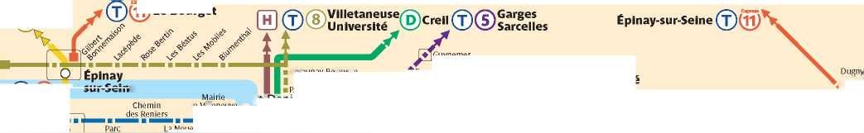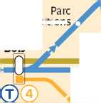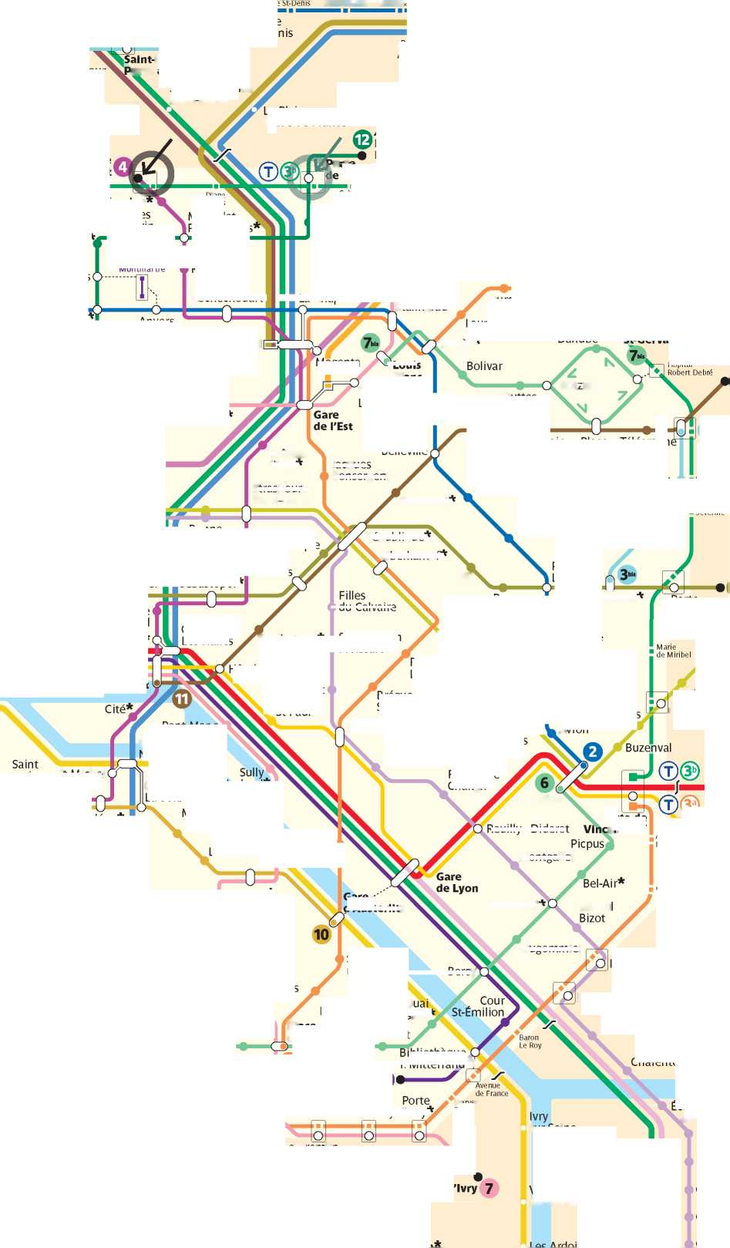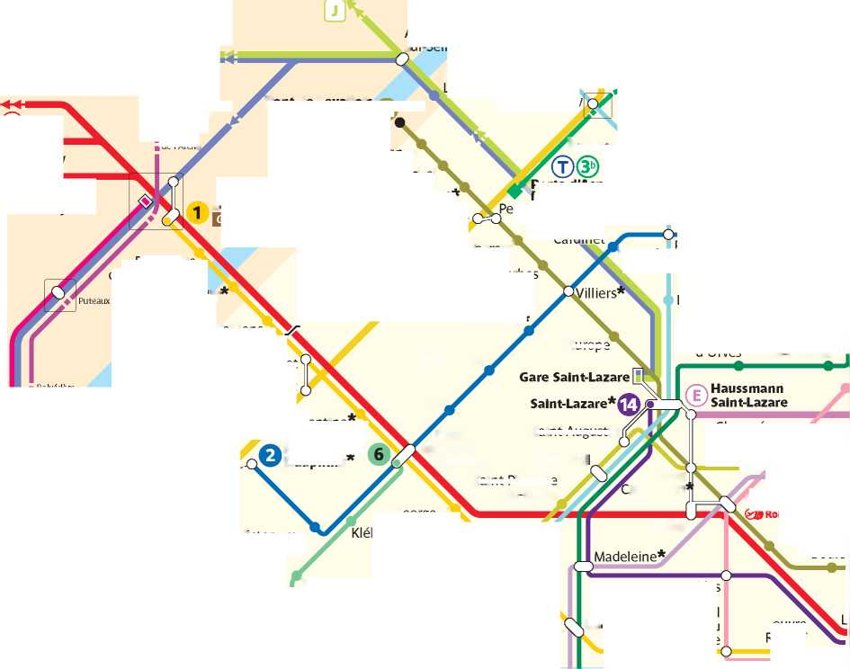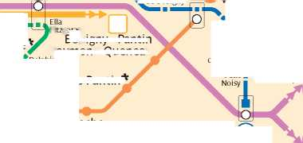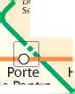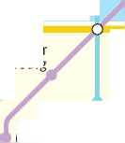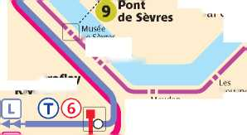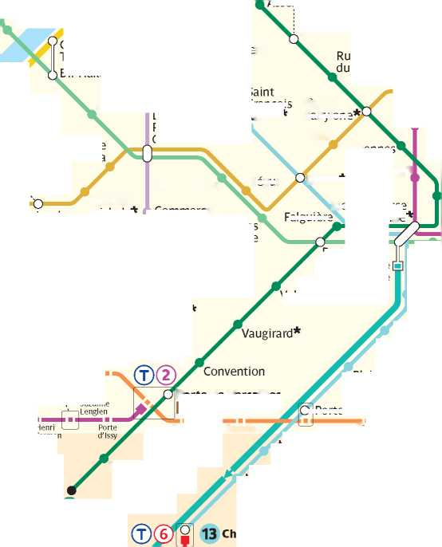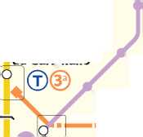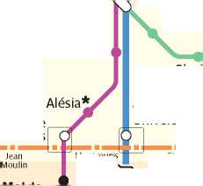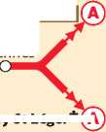

**The guide is edited, coordinated and updated by**

**WATIZAT association**

**(under the 1901 association law)**

The guide is updated every month and is available in the  
following languages:

French

English

Arabic (litterary)

**Thank's to the volunteer translators, mostly exiles themselves, and the  
supportive printers who made this guide possible and multilingual**

This guide is updated every month  
Download the latest version guide on your phone !  
**[www.guideasile.wordpress.com](http://www.guideasile.wordpress.com)**

Contact us:

**[contact@watizat.org](mailto:contact@watizat.org)**

Feel free to print and distribute this guide to people who might need information.  
This guide was made for free

1. Clothes and hygiene kits distribution

   FREE
2. Rue Saint Bruno, 75018 Paris ® Chateau Rouge (line C ) Barbes Rochechouart (line /0) La Chapelle (line 0 and @ )

   O Saturday and Sunday from 8:30am